Haptic communication and guide dog
The booklet's target groups are the combined sight and hearing impaired, deafblind, visually impaired and the network around these people. This could be, for example, next of kin, guide dog instructors/trainers, professionals, interpreters and companions.
The signals in this booklet are an addition to the haptic communication platform. The platform is described in the book "Haptics communication" and the signals are also explained in the App "Haptics: Pocket edition".
C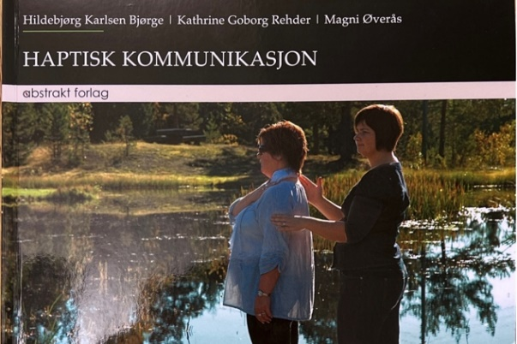 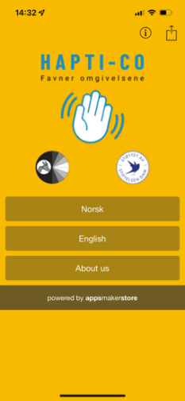
This means that room description and description outside will not be dealt with in this booklet. However, such information is also important for the recipient in this context. Describing the surroundings out of place, roads, intersections, buildings, where there are a lot of people, in addition to much else is useful information. Such information provides an overview and the opportunity to make a choice.
Haptic guidance is also an important area of the platform, and "haptic and guide dog" is an extension of this. There are several things that should be clarified in the cooperation between the recieiver with guide dog and the provider. The provider must be placed approximately an arm's length behind the receiver`s on the right side. The location is so as not to disturb the dog. It is still the dog who must guide and the provider shall give information about the surroundings and the dog's actions. Haptic signals will strengthen the cooperation of the team.
The signals described below are a mixture of signals from the norwegian haptic platform and new signals established during the pilot project. The project is a collaboration between: Eikholt - national resource center for the deaf-blind, Hapti-co, experienced guide dog teams and schools for guide dogs
The guide dog must still be the obstacle remover. A signal that explains that the team is encountering an obstacle makes it clear to the guide dog user that he must follow the dog, praise and not correct. Using haptic signals with a guide dog does not aim for receiver to always use a companion. It can contribute to increased security for the team. Some will benefit from using haptics when learning new skills. Many people will experience better contact with their dog. The aim is not to always use a haptic provider in everyday life but it`s an additional tool to the used in certain situations. Ex. when the team are in new surroundings.

Marked signals (*) are primarily intended for guide dog instructors.
In the haptic system, reference signals are an important element. The reference signals are always given first if the context for the upcoming signals has not already been established. What is new in relation to "DOG" is where you place the signal tells whether it is about your dog or someone else's dog.

Quotes from the project:
"The signals the interpreter gave me along the way gave me a lot of security. Everything that happened around me with traffic, especially with cars! Then noise from the surroundings, especially with the Roger pen. The haptic signals for curbs up and down, and stairs, gave me the opportunity to give the right command to the dog".
"It was very nice to be told about crossing roads in advance, especially in a place I'm not familiar with."
"Great description of what was in the aisles and places in the shopping centre. Then I got more overview and control".
"Received a signal that there were small dogs on the right, and that we could go to the left, so we avoided a situation where the dog barked and had to show who was the biggest."
"The timing of the signals is important for me to be able to command my dog. Its very important for the job to flow, to get flow in walking and stopping".
"We went towards the front door, there was an obstacle. The provider signaled it as danger, I chose to ignore the signal and trusted the dog. The dog handled the situation, and then I had an eyeopening experience. I can receive signals, but can choose to use them or not. In that way I also get to check whether the dog is doing the right thing."
"It's important to collaborate and make agreements. There are a lot of things that have to work together and it's not done in the blink of an eye, but it's very exciting."

The signal "DOG" given on the receiver's back says that it applies to the receiver's dog in particular.
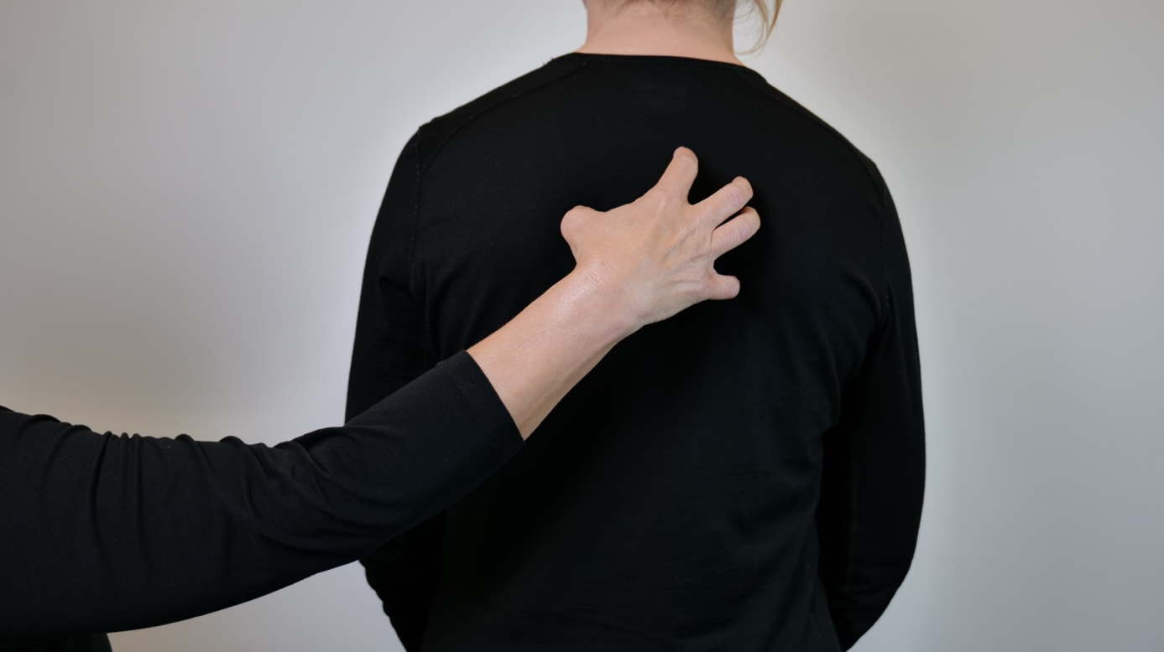
Claw hand is placed on the receiver's back, move the fingers slightly inwards twice.

The signal "DOG" given at the top of the receiver's upper arm, says that the following signals apply to other dogs.
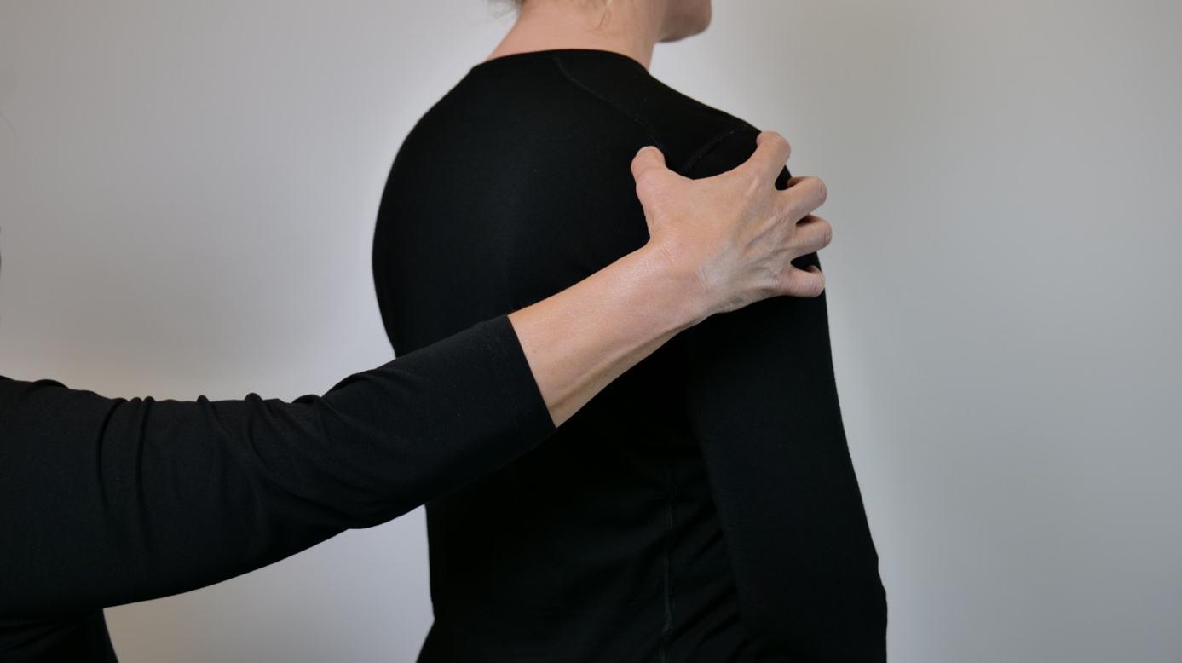
Claw hand is passed at the top of the receiver`s upper arm, move the fingers slightly inwards twice.

Confirmations / information
« YES» Yes , fine, go ahead, start
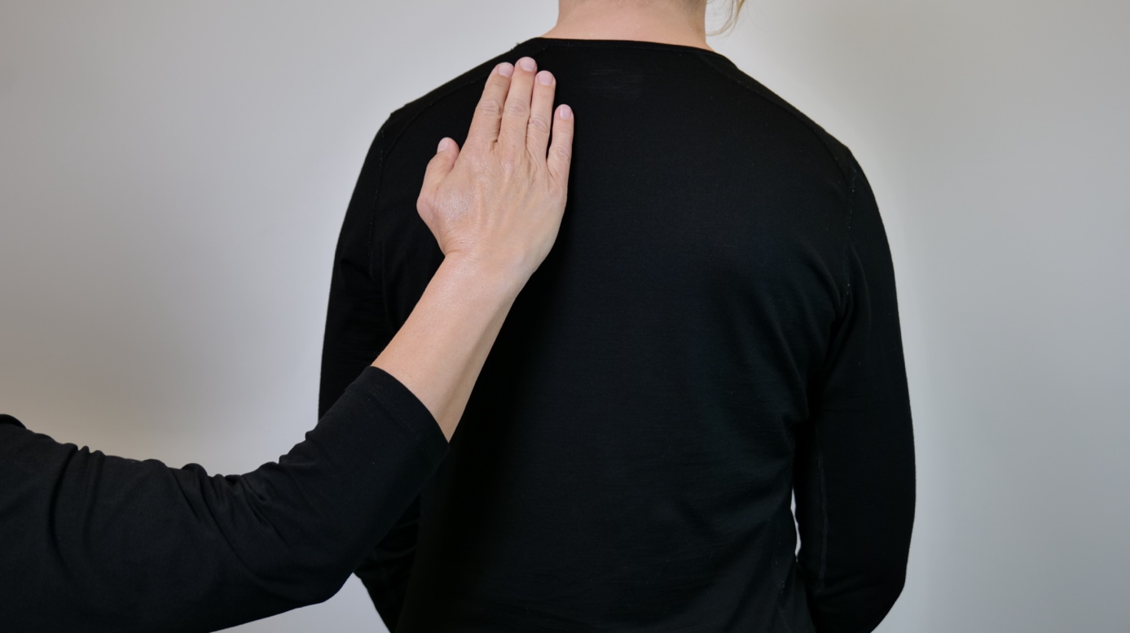
Lightly pat 2-3 times with a flat hand on the top of the receiver's back.

"NO"
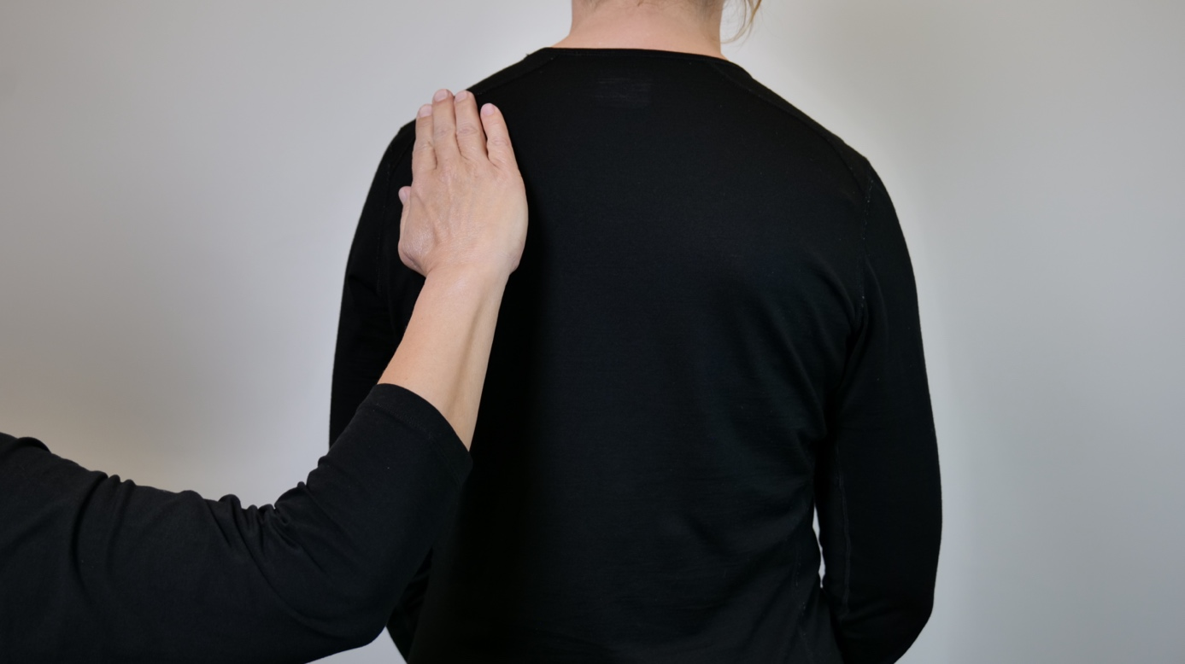

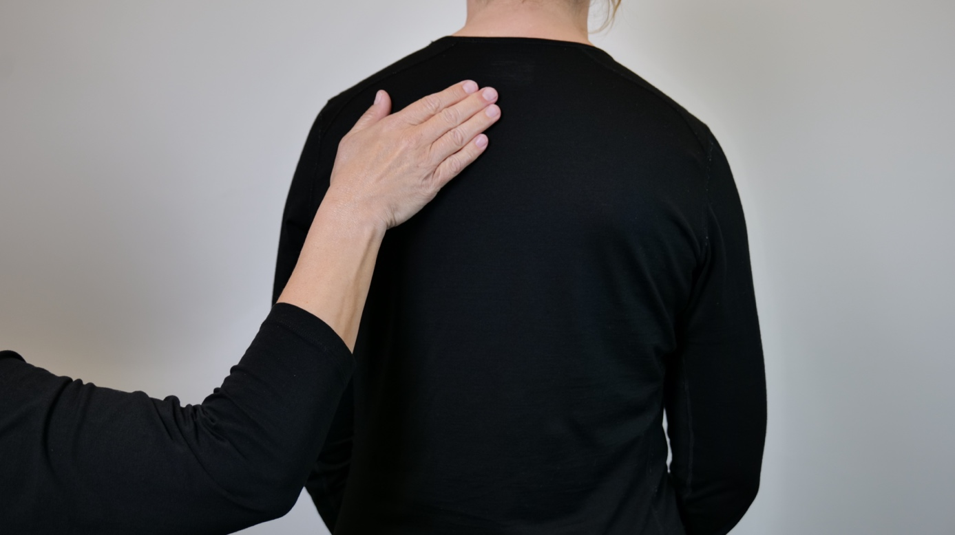
Place flat hand with joined fingers at the top of the receiver s back, stroke the hand from left to right, repeat the movement a couple of times back and forth

The "INFORMATION" signal is given when the provider needs to give more complementary information.
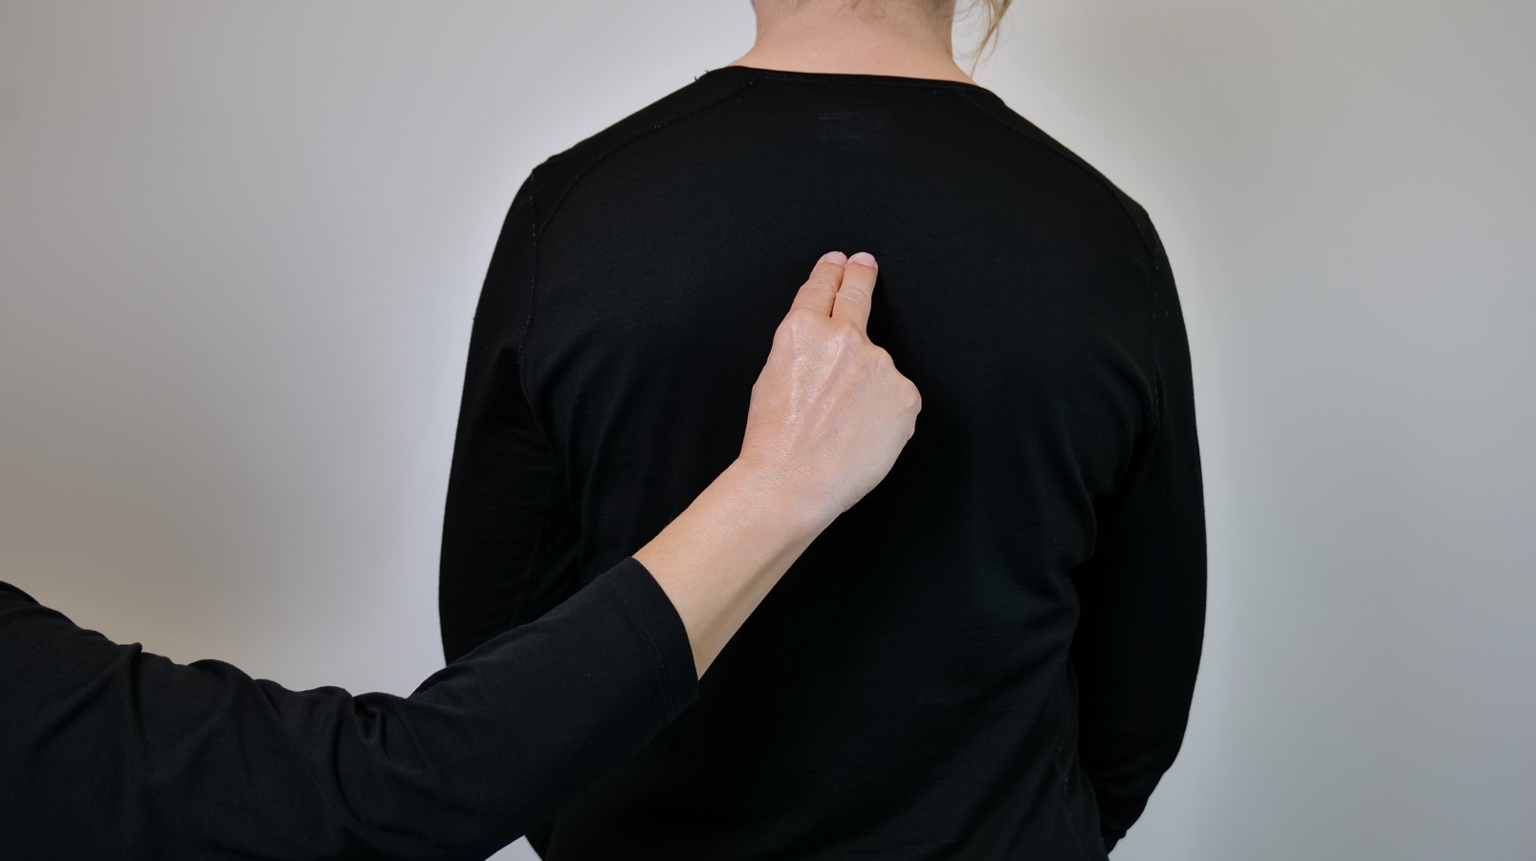
Write an "i" on the recipient's upper arm or back

Action signals dog:
For all these signals, first give the position of the signal dog to indicate whether the action concerns your own or someone else's dog. The action signals are primarily carried out on the receiver's back, but can also be placed on the upper arm.
"SITTING"
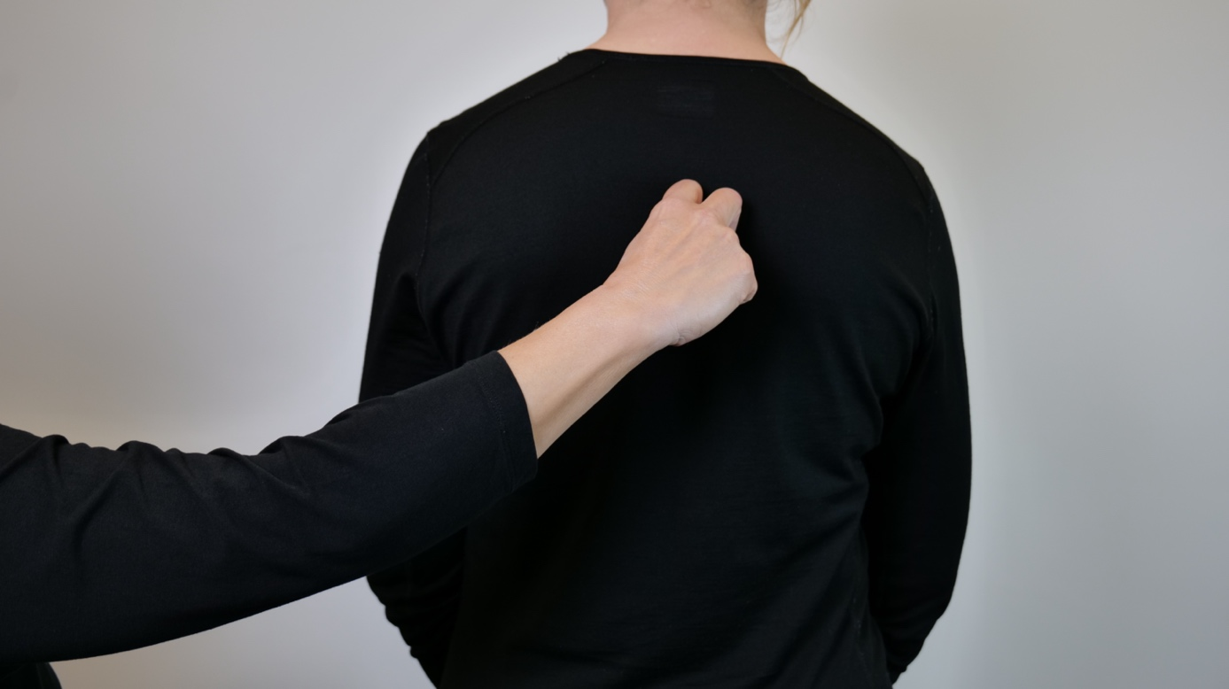
V-hand with bent fingers, palm facing down, press the fingers towards the receiver's back and pull down slightly.

"IS LOCATED"
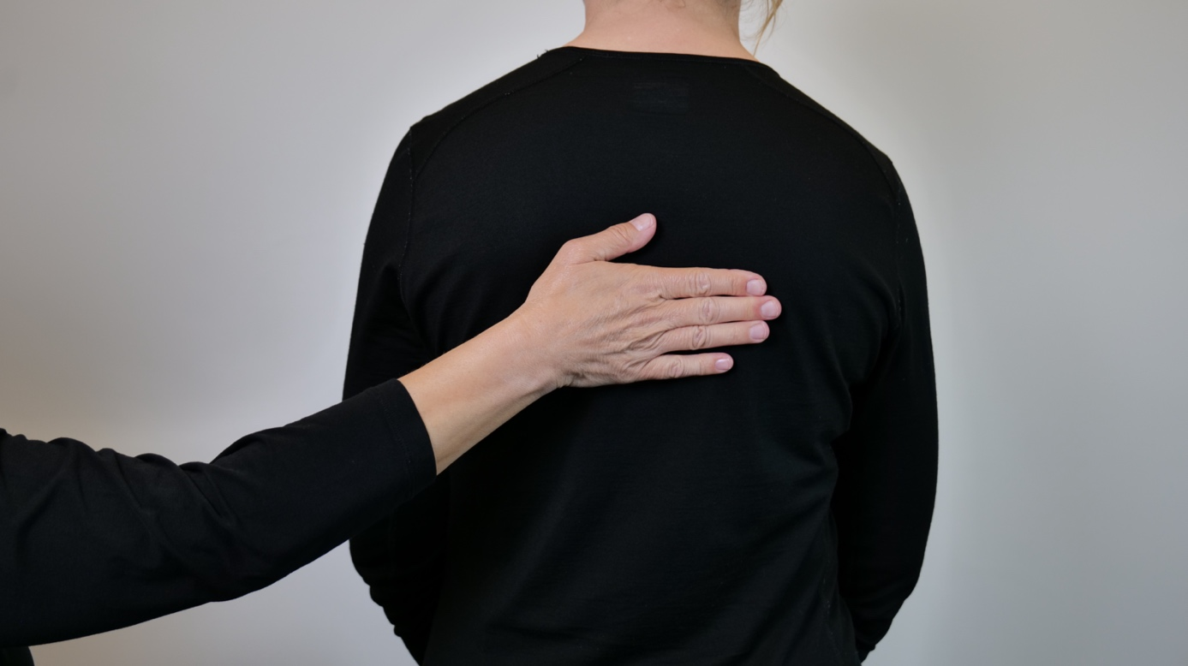
A flat hand with the palm in is placed on the receiver's back.

"EATS"
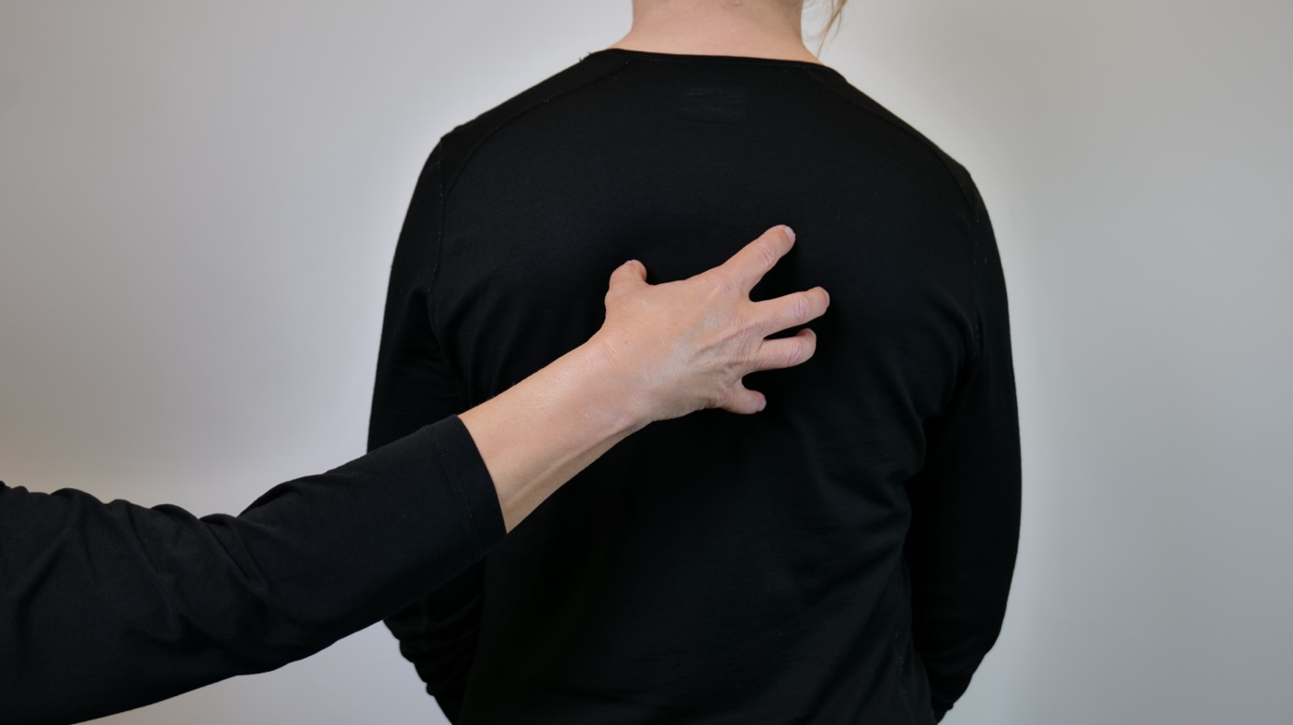
Place claw hand on the recipient's back, make a circular motion, bringing the fingertips together at the end of the motion. Repeat twice.
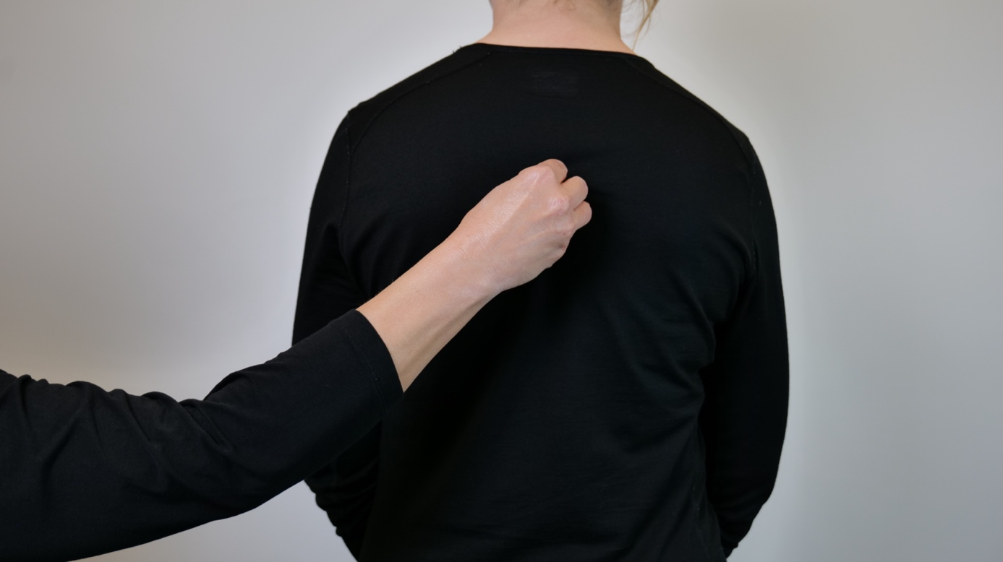

"LICK"
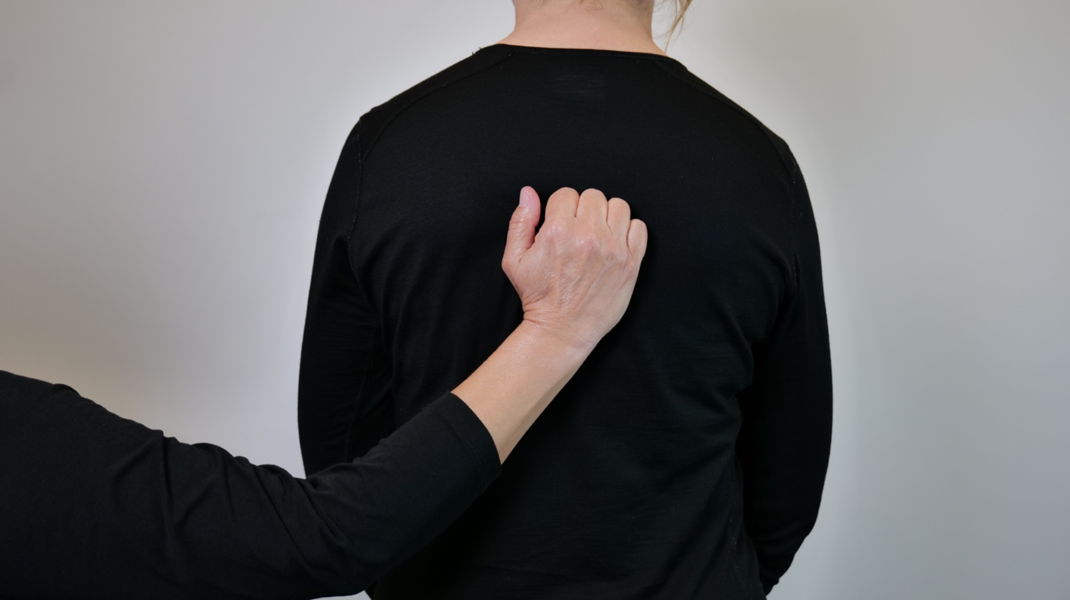
Place your palm against the receiver's back, curling your fingers into a fist. Hold the contact and move all fingers up, repeat twice.
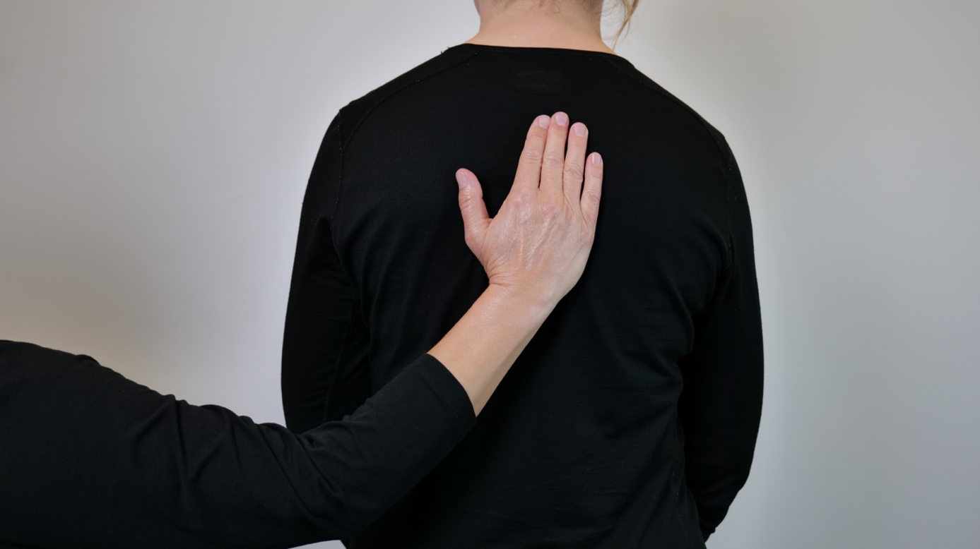

"SNIFF"
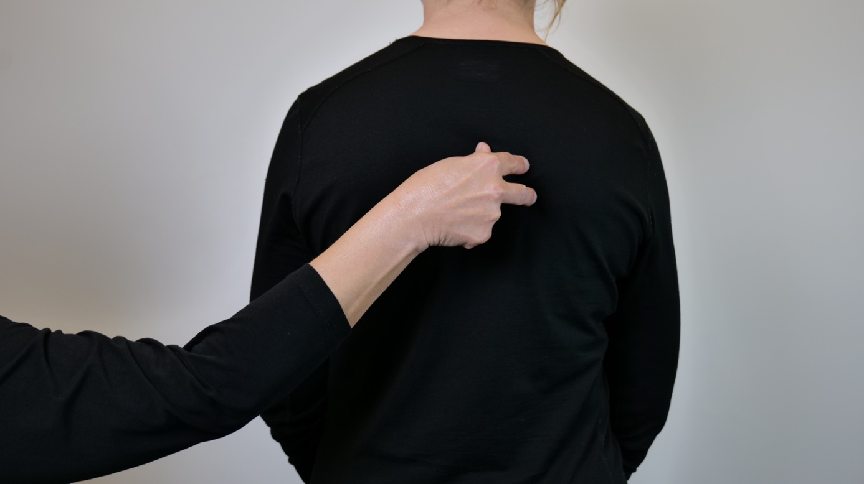
Thumb, index finger and middle finger come together, move out and together quickly several times.
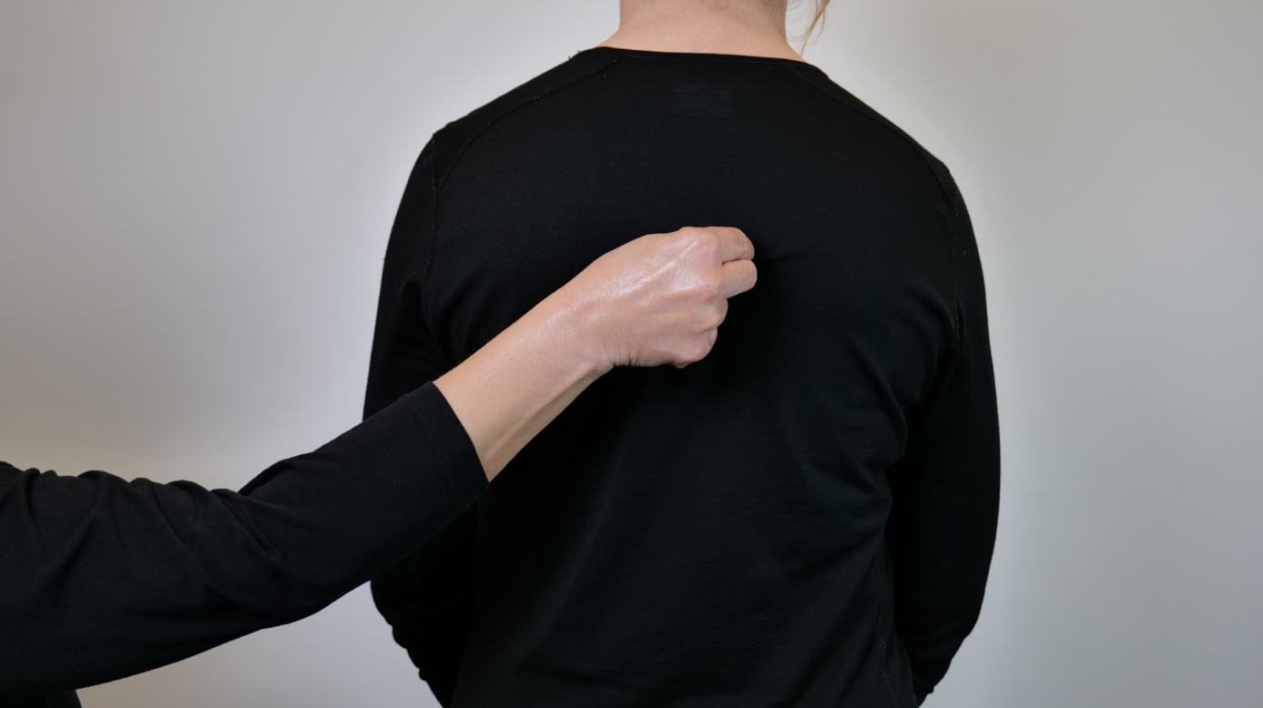

"RUNNING OFF" - the signal for "GO" and "DIRECTION"
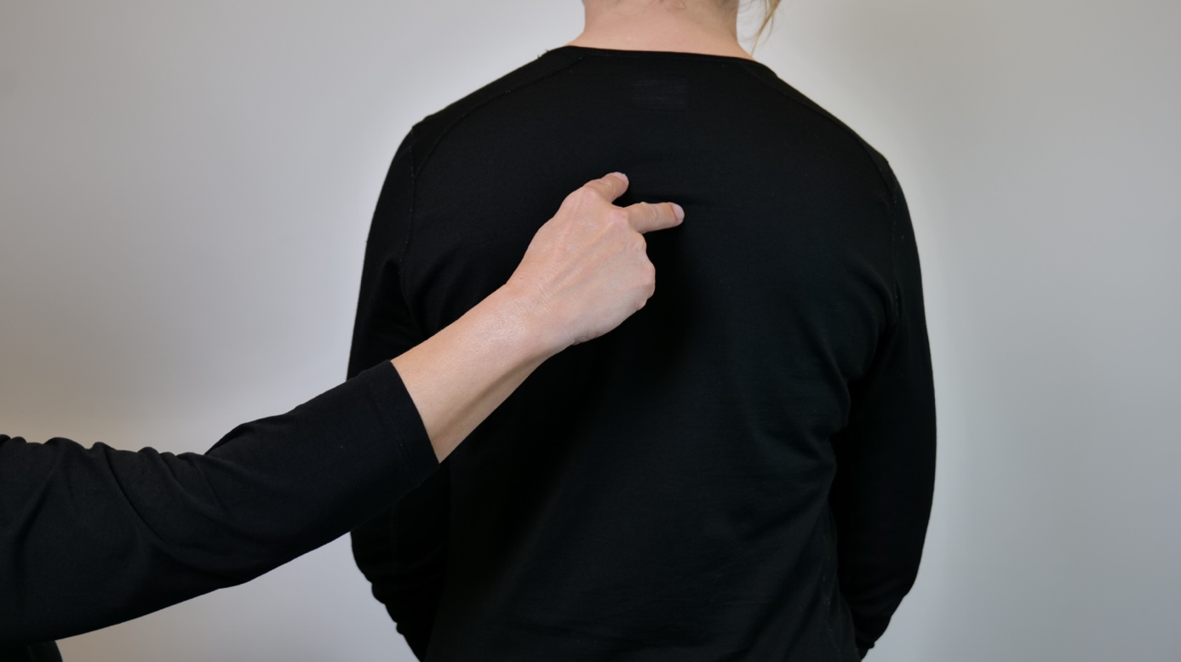
WALK, V shaped hand is placed on the receiver's back, index finger and middle finger make a walking movement with slightly fast steps. "GO" in the direction the dog is running, if necessary add the signal for "DIRECTION".
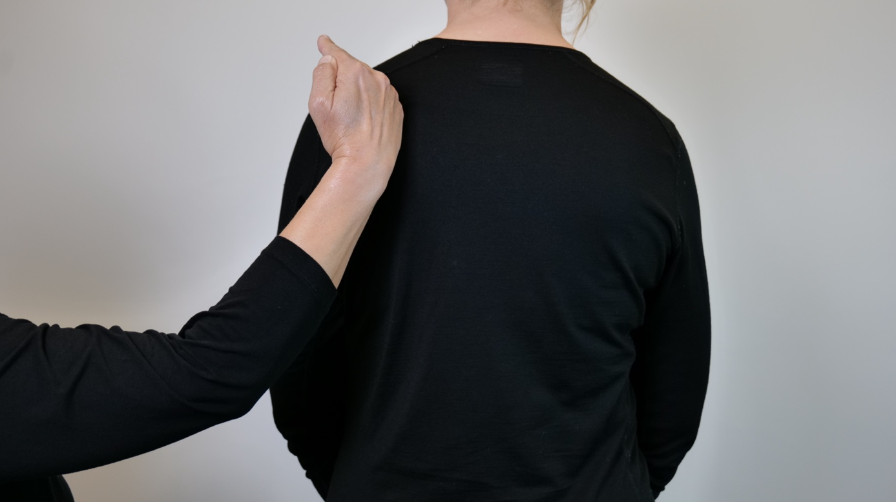

"BEGGAR"
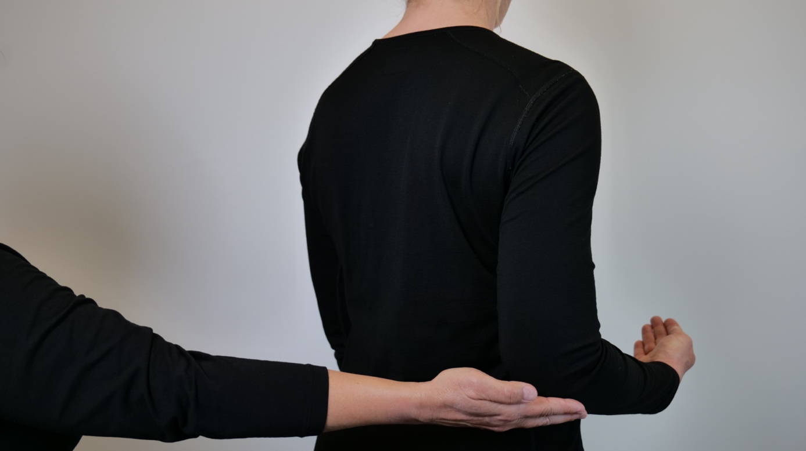
Flat hand is pushed up against the elbow.

"POOP"
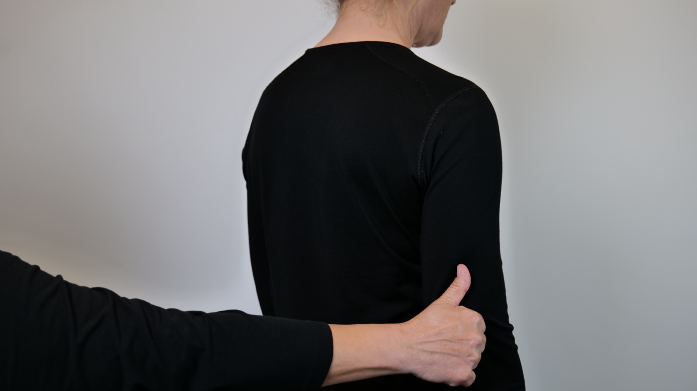
Hand shape, "thumbs up", is placed at the bottom of the receiver's upper arm, pull the hand down and past the receiver's elbow.

"PEE"
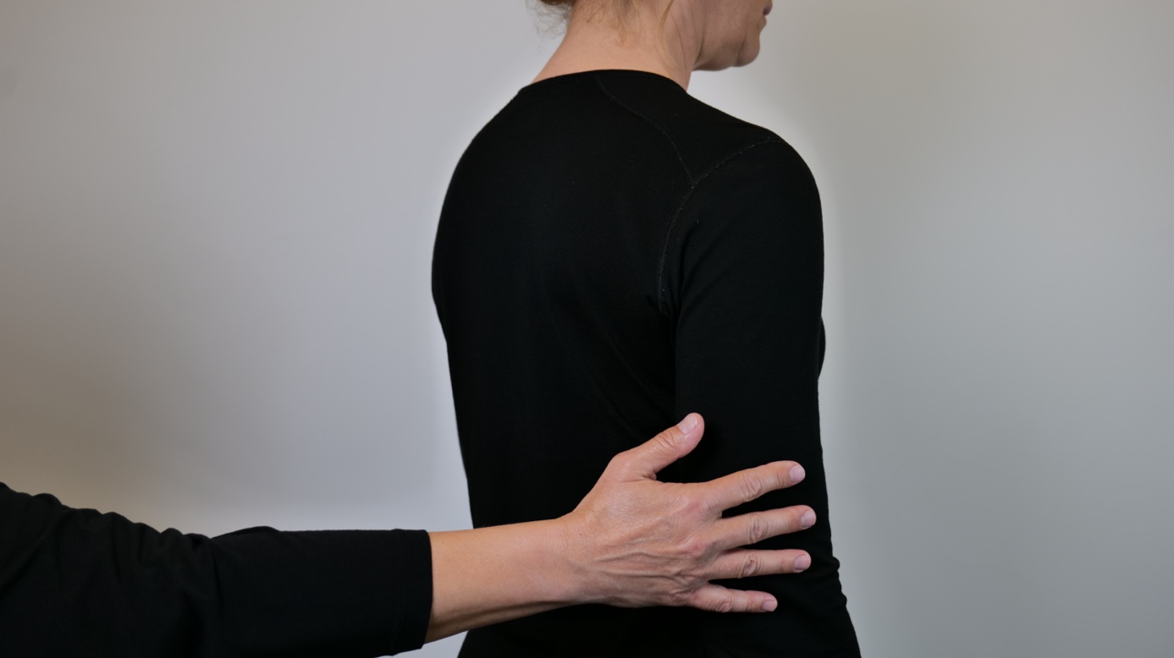
Playing fingers, as if playing the piano, the movement is performed at the bottom of the receiver's upper arm.

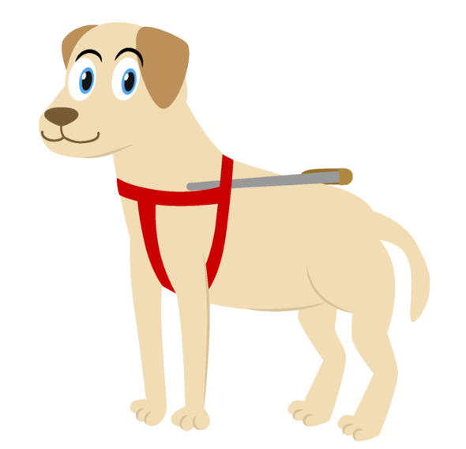

"DRINK"
The signal for "WATER" + the signal for "LICK". The signal for water: Place your fingertips together at the top of the receiver`s upper arm. The fingers are spread at the same time as the hand is moved downwards towards the elbow.
+The signal for "LICK"
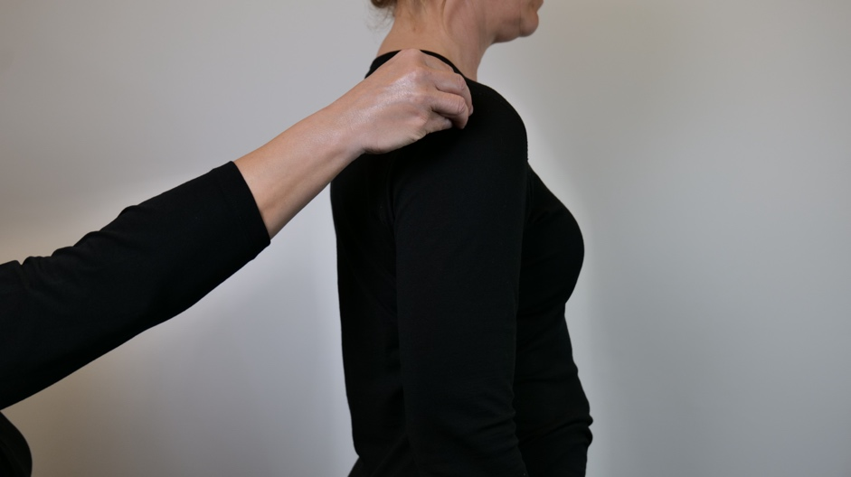
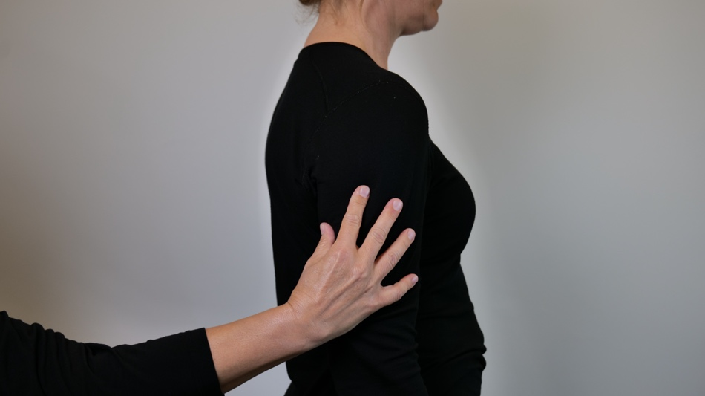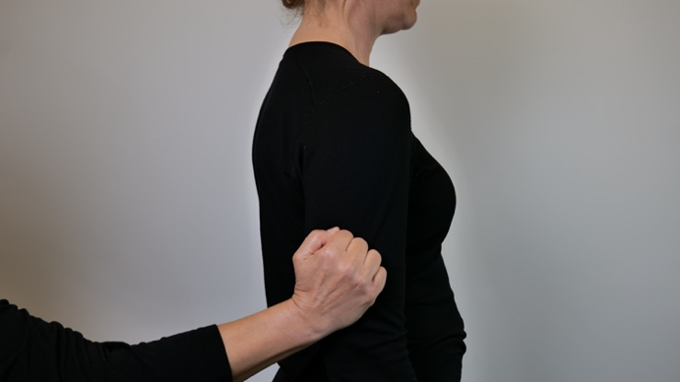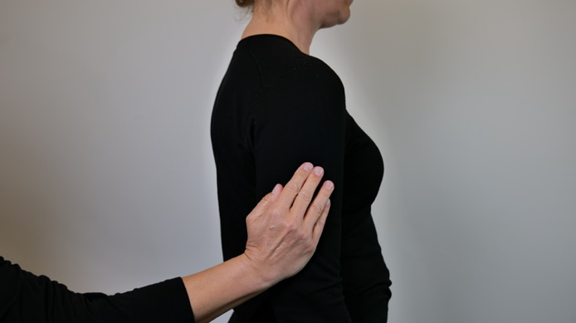

"BARKING"
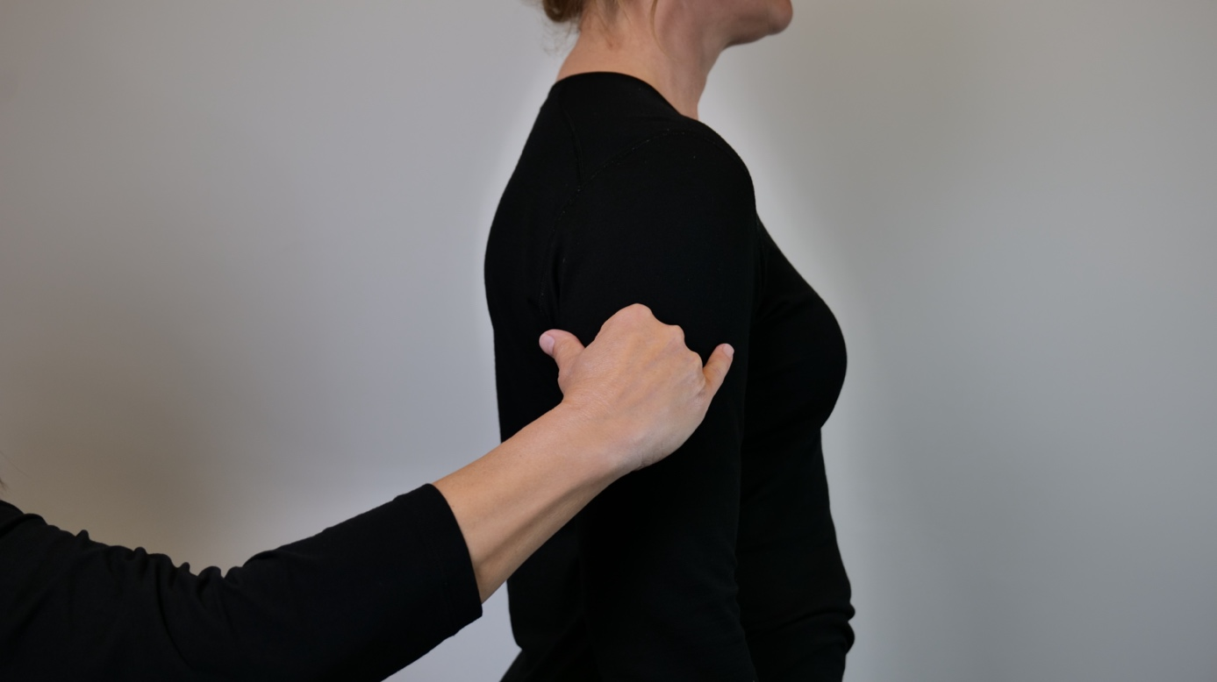
The signal for "DOG" + the signal for "NOISE". The signal for "DOG" is described above. The signal for noise; hold the little finger and thumb out and bend the other fingers in. Place the hand horizontally on the receiver's upper arm, pull the hand back and forth so that the little finger and thumb alternate hitting the upper arm.

"PIPPING"
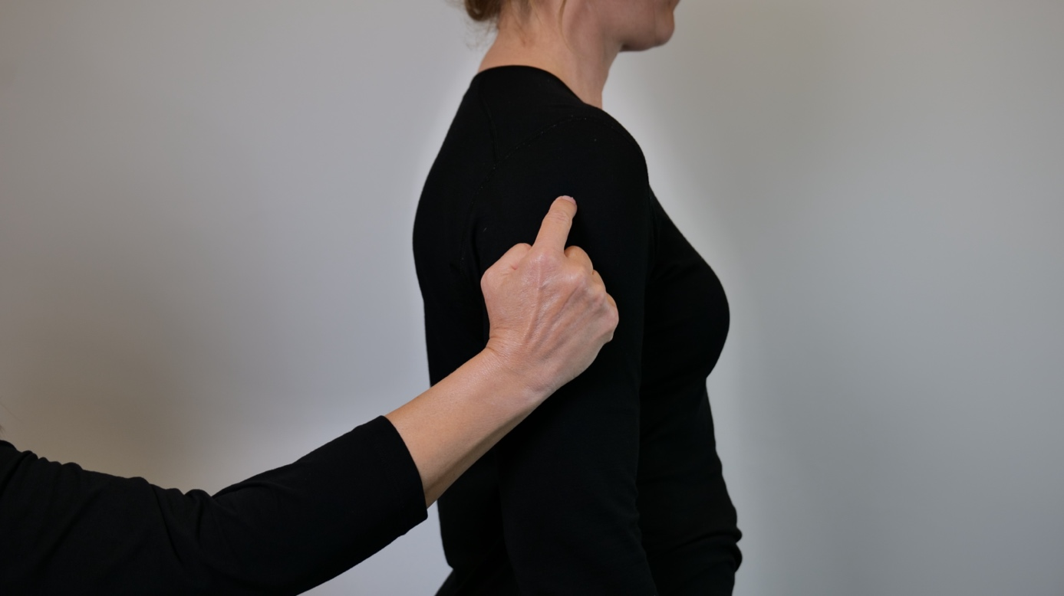
The signal for "DOG" + place the index finger on the upper arm, and take two short pokes downwards.

"GROWL"
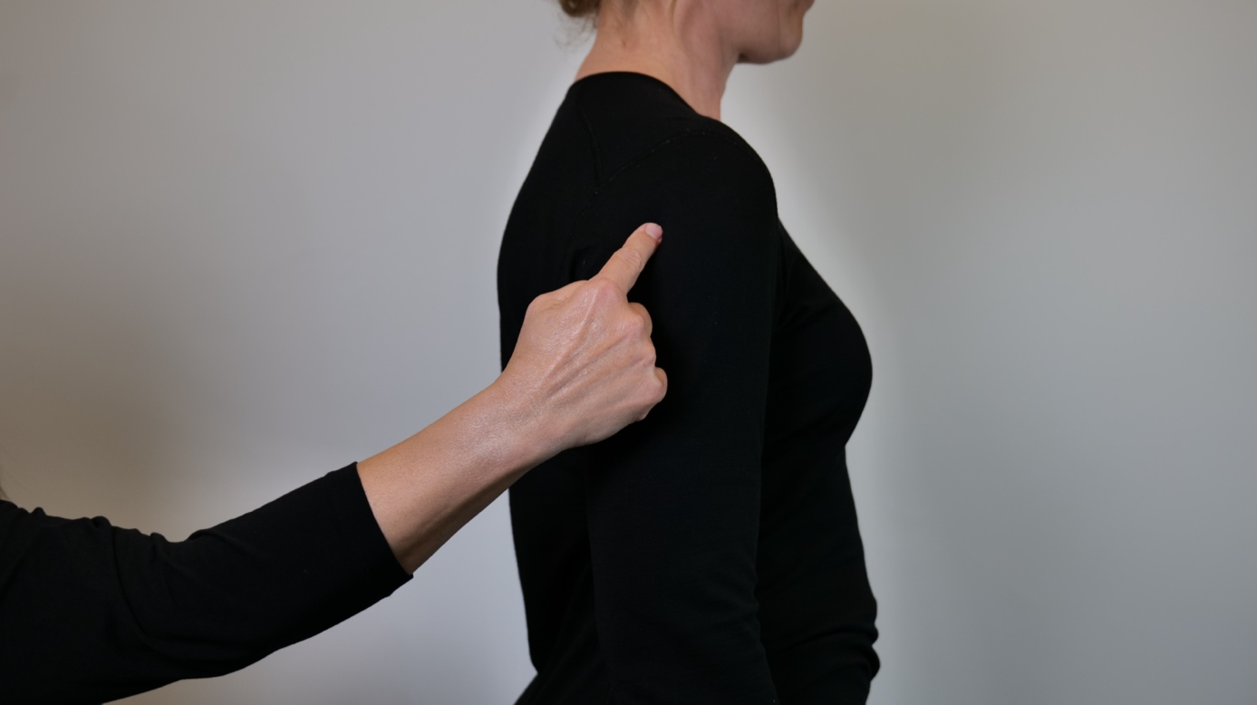
The signal for "DOG" + write a "K" on the receiver's upper arm
K

"WAGGLING"
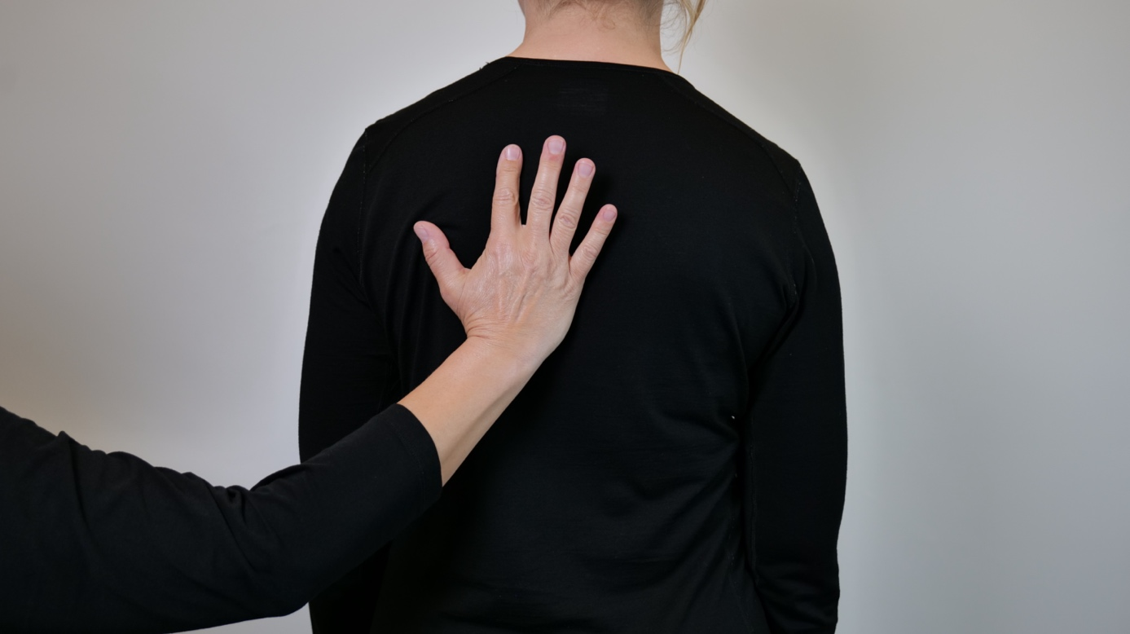
The palm is placed on the receiver`s back, maintain contact. The fingers are held up, but only the index finger has contact with the back, move the index finger back and forth a few times, from right to left.

The dog's behaviour: For all these signals, first give the location of the signal dog to indicate whether the action concerns your own or someone else's dog. The action signals are primarily carried out on the receiver's back, but can also be placed on the upper arm.
"HAPPY"
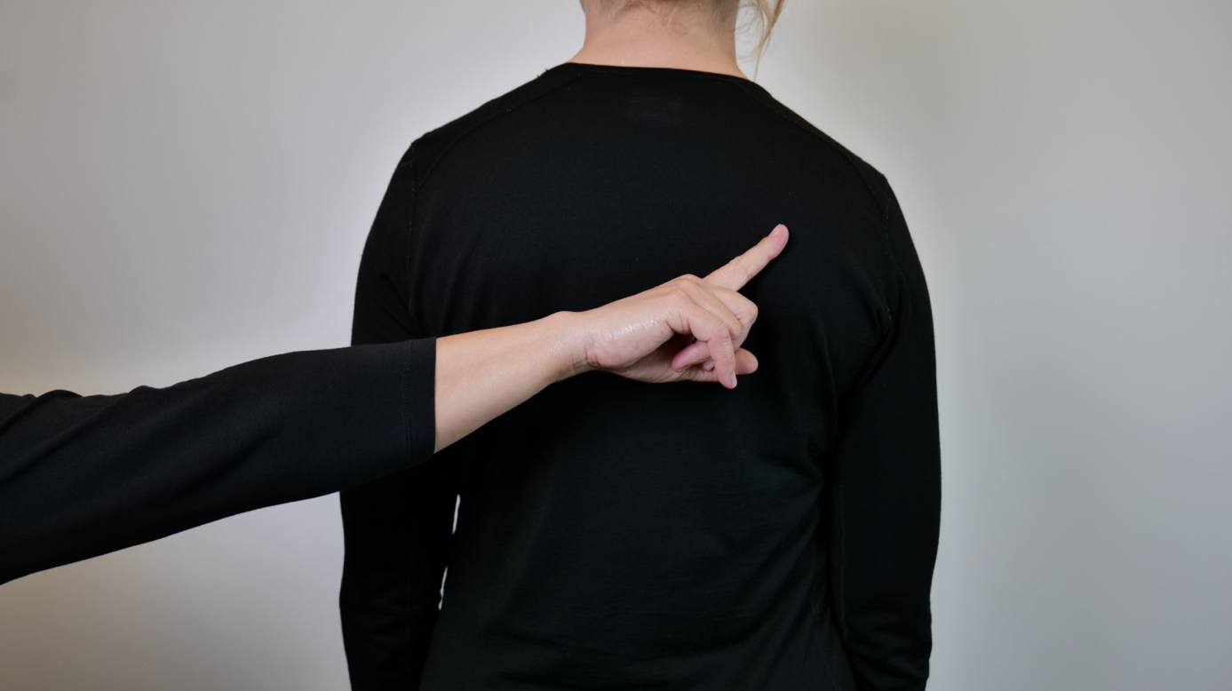
The index finger draws a downward arch on the receiver's back, like a smile.

"AGGRESSIVE"
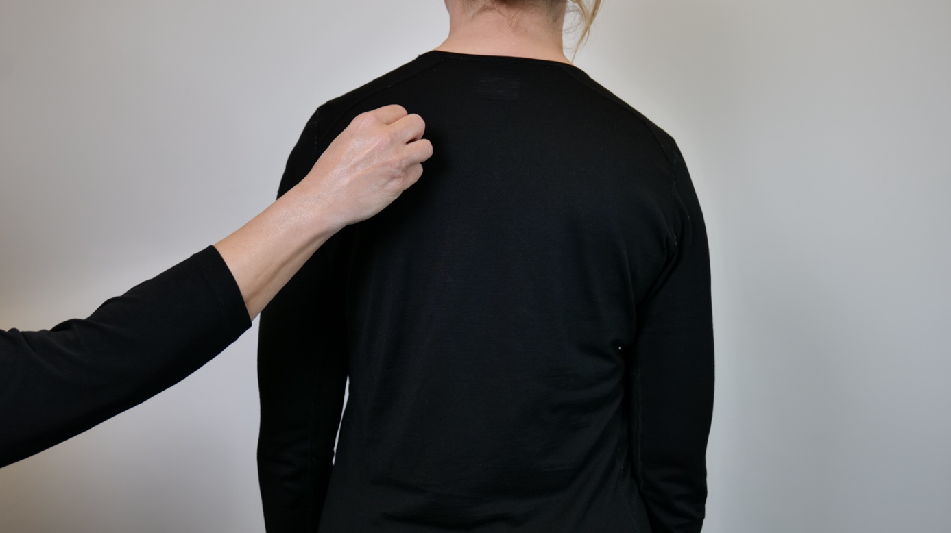
Place joined fingertips of one hand on top of receiver's shoulder blade. Open the fingers into splayed fingers in a quick motion twice.
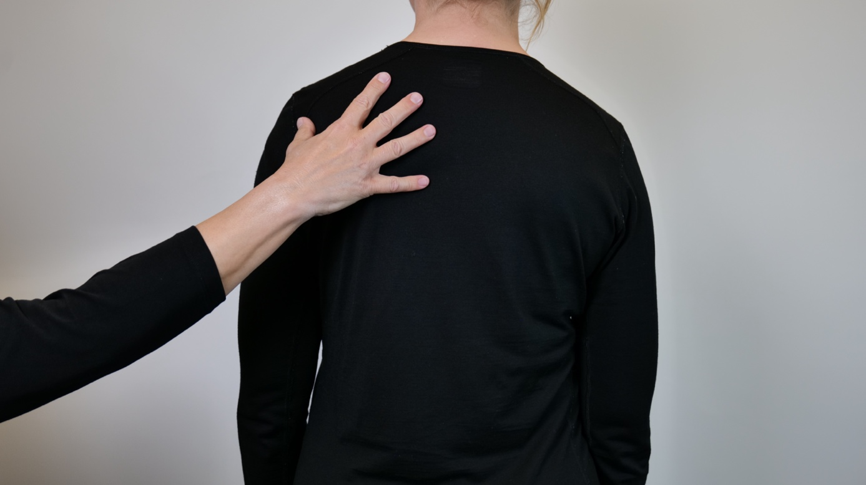

"UNCONCENTRATED"
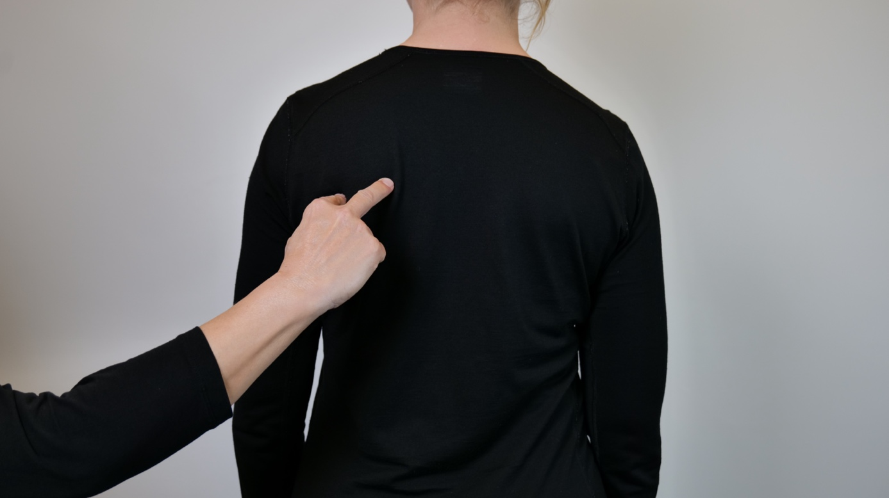
Using spreading index finger and middle finger, place one finger at a time on the receiver's back. Make an upward arc across the back to the other side with both fingers.
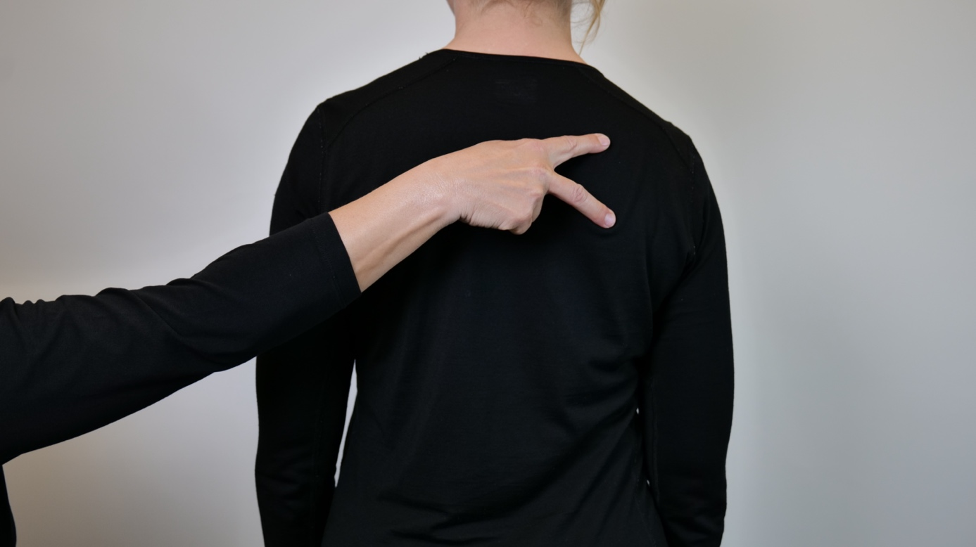

"LOOKING AT YOU"
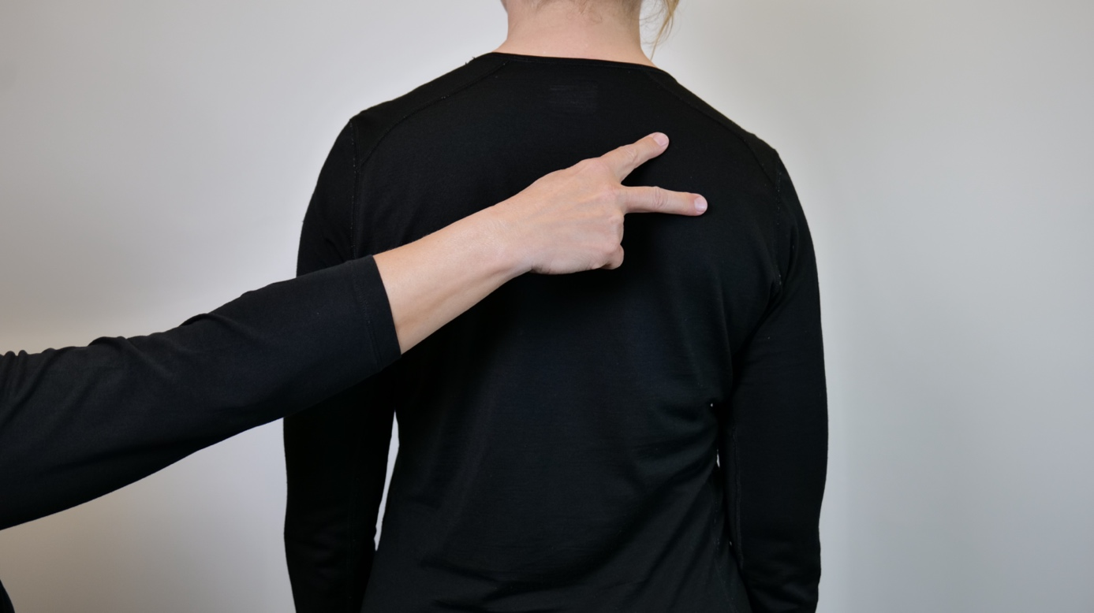
Use the spreading index finger and middle finger, mark one finger at a time on the receiver's back in the direction the dog is, pull the fingers at the same time towards the middle of the recipient's back.
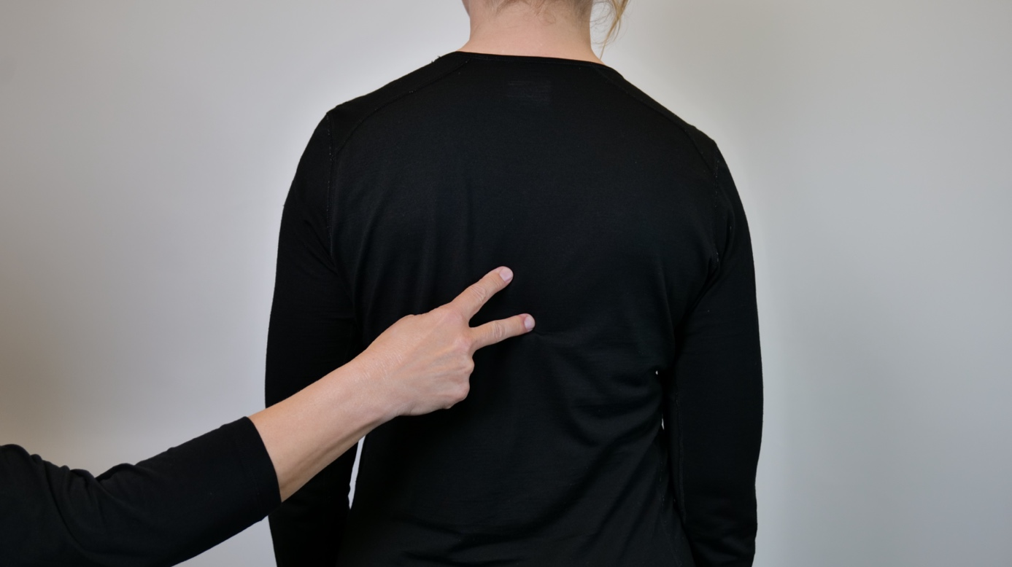

Collar - remember to place the signal for your own or another dog before the signals below are performed
"COLLAR"
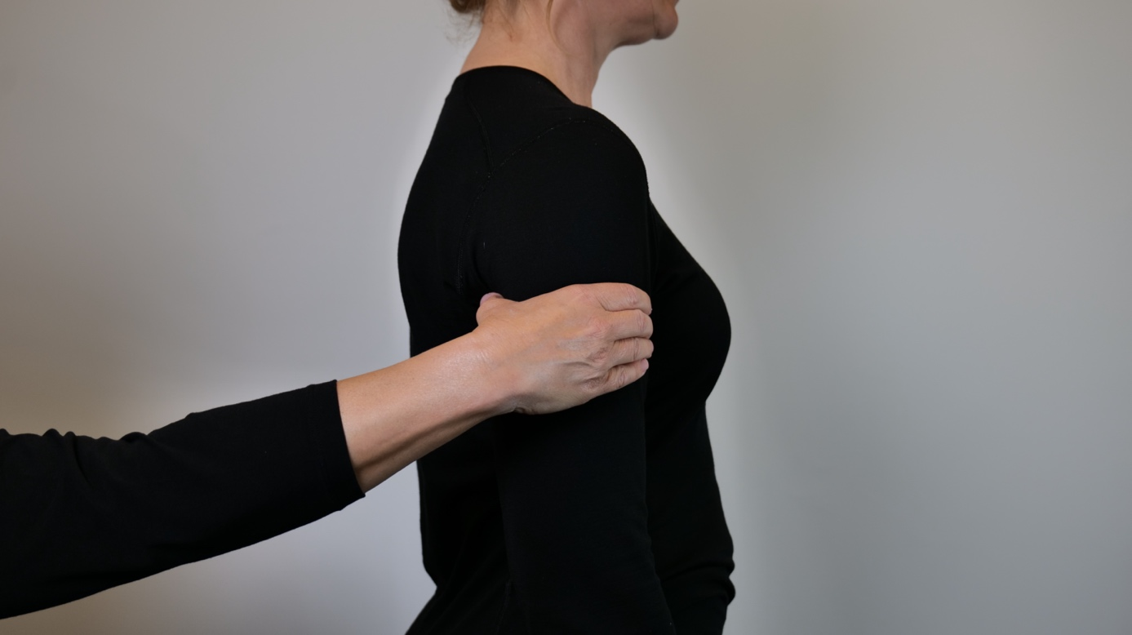
Use C-shaped hand and place on receiver's upper arm, like around a glass.

"COLLAR WITH HARNESS"
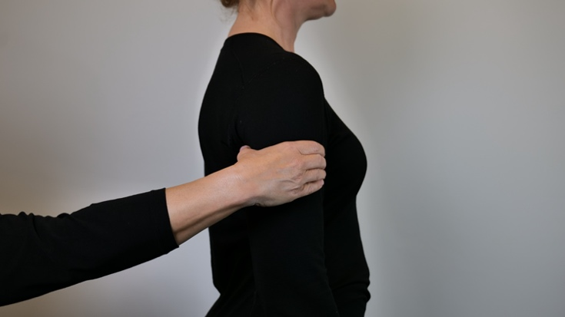
The signal for "Collar" + place thumb and forefinger on either side of the receiver's upper arm, pull these down over the upper arm from shoulder to elbow.

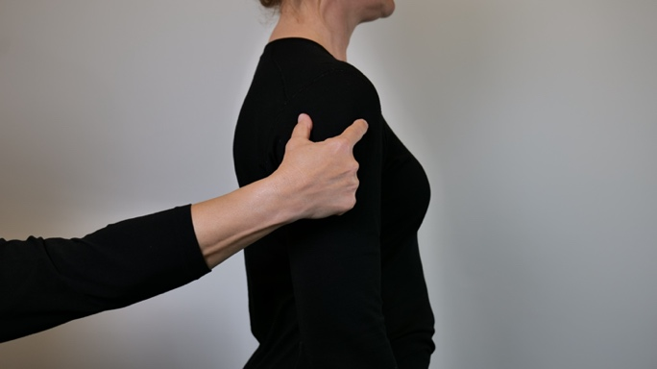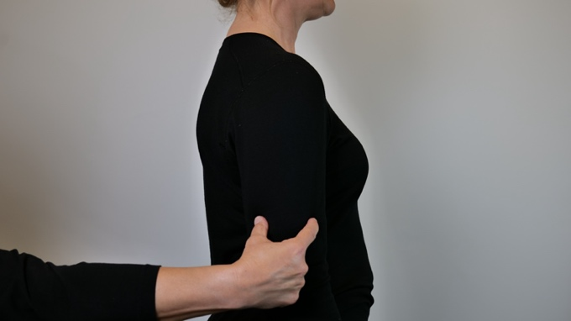

"COLLAR WITH CABLE"
The signal for Collar + drag the index finger down the receiver`s upper arm, from shoulder to elbow.
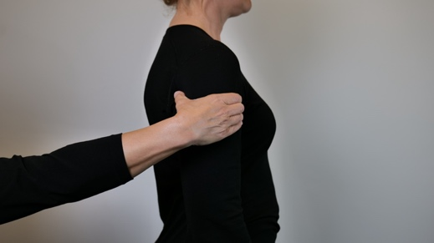
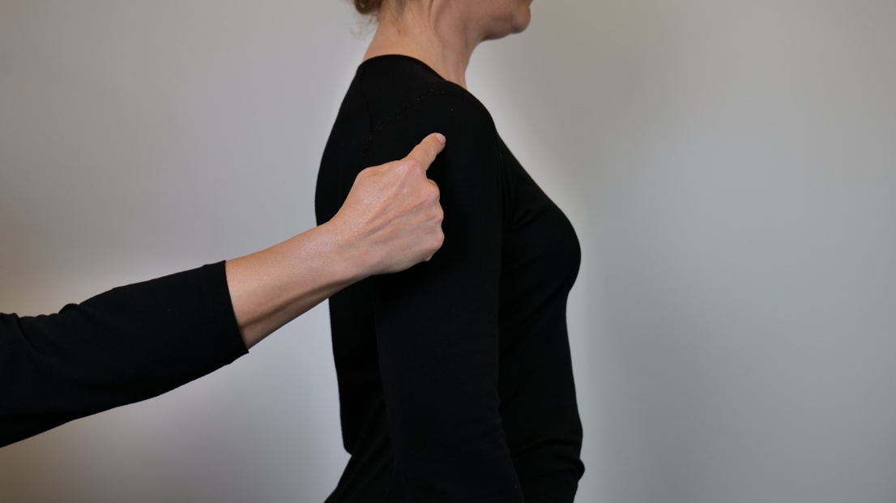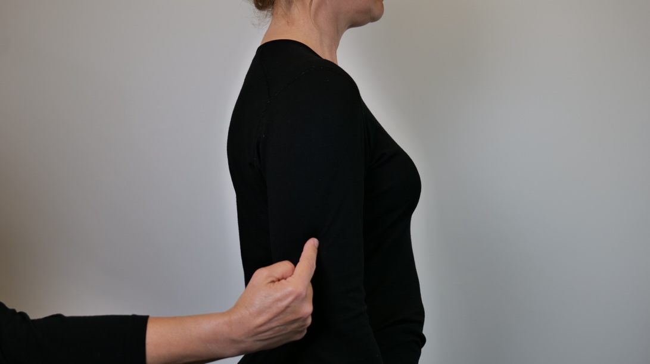

"COLLAR WITH FLEXIBAND"
The signal for "Collar" + drag the index finger up and down the receiver's upper arm, from shoulder to elbow and up again.
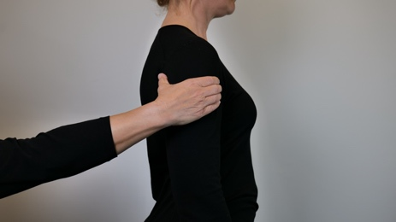
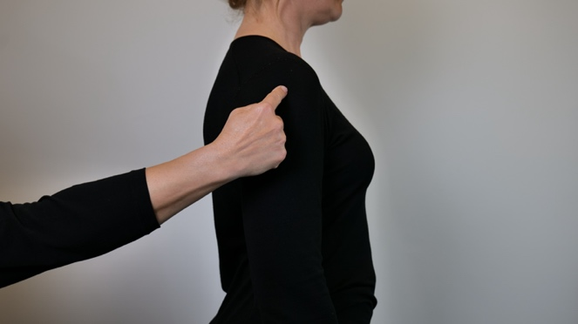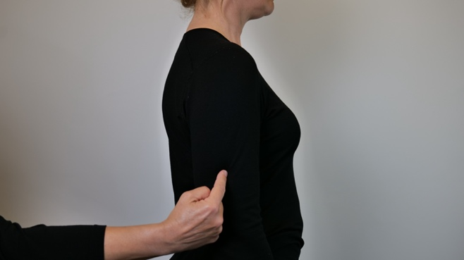
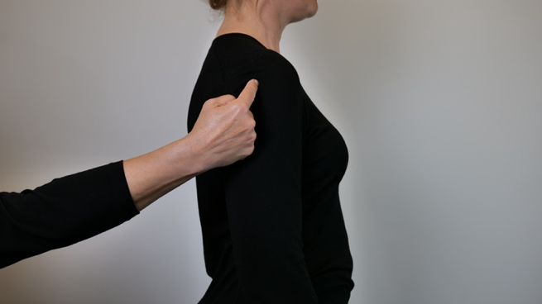
"LOOSE DOG"
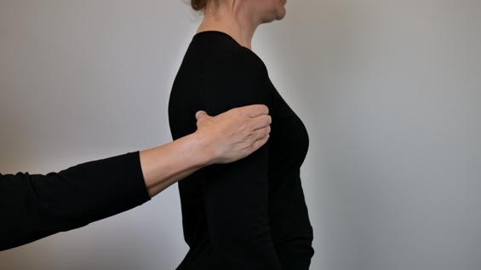
The signal for "collar" + flat hand with fingers together, stroke horizontally over the upper arm.
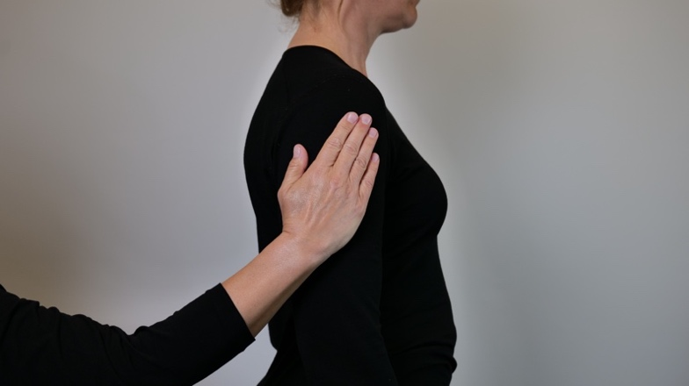
Other useful signals:
"IN FRONT OF" (*)
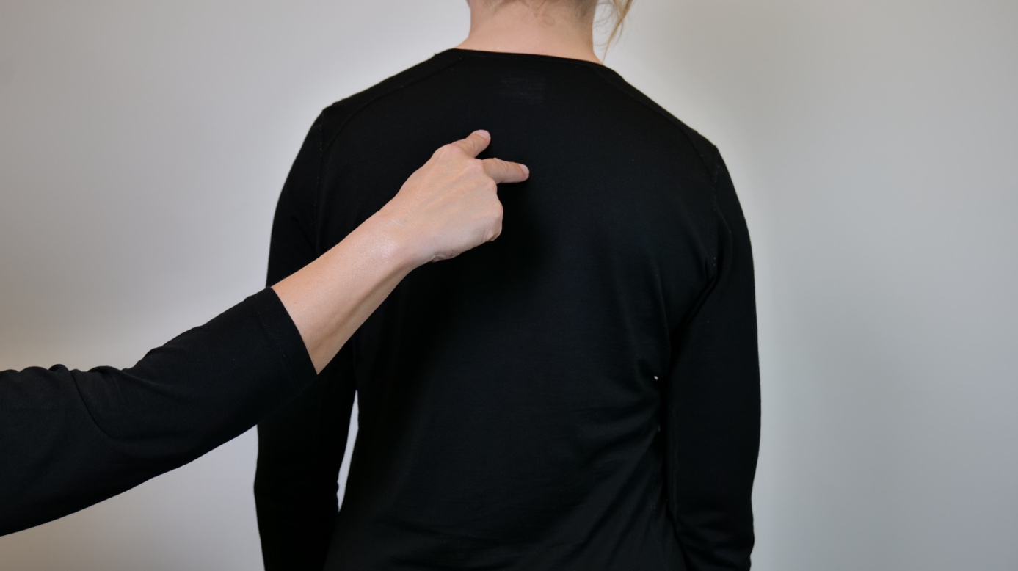
The signal for GO – V-shaped hand is placed on the back, index finger and middle finger make a walking movement from the middle of the receiver's back and towards the neck.

"OBSTACLES - FOLLOW THE DOG"
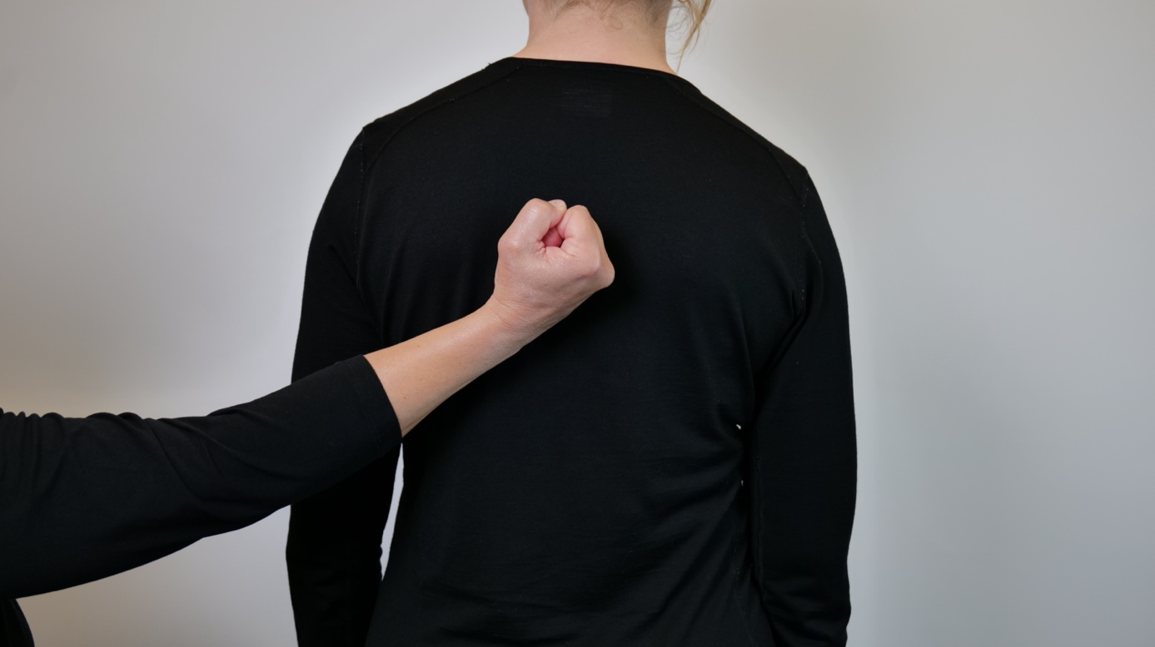
The clasped hand is placed on the receiver's back with the little finger side in.

" GIVE PRAISE" (*)
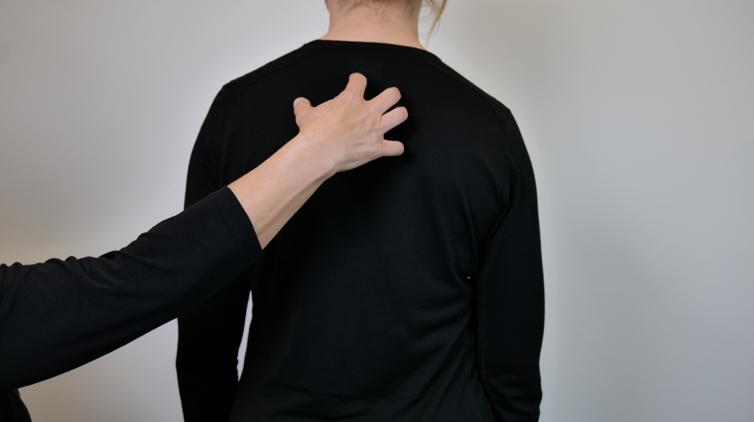
The signal "DOG" is placed on the receiver's back, then stroke with both hands, every other time, with a flat hand on the receiver's back.
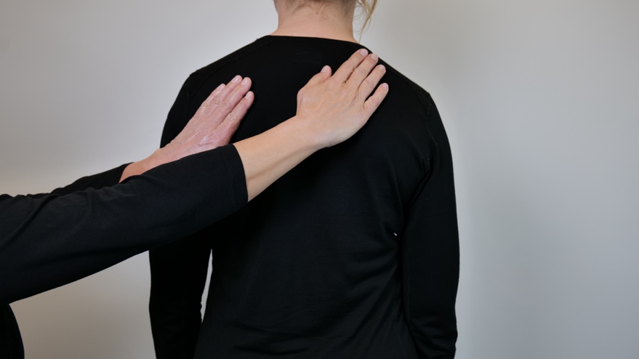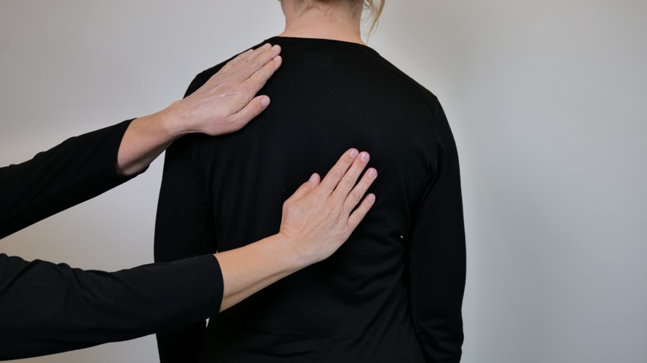

"UNSURE" The signal for "DOG" + draw a big "?" (*)
?
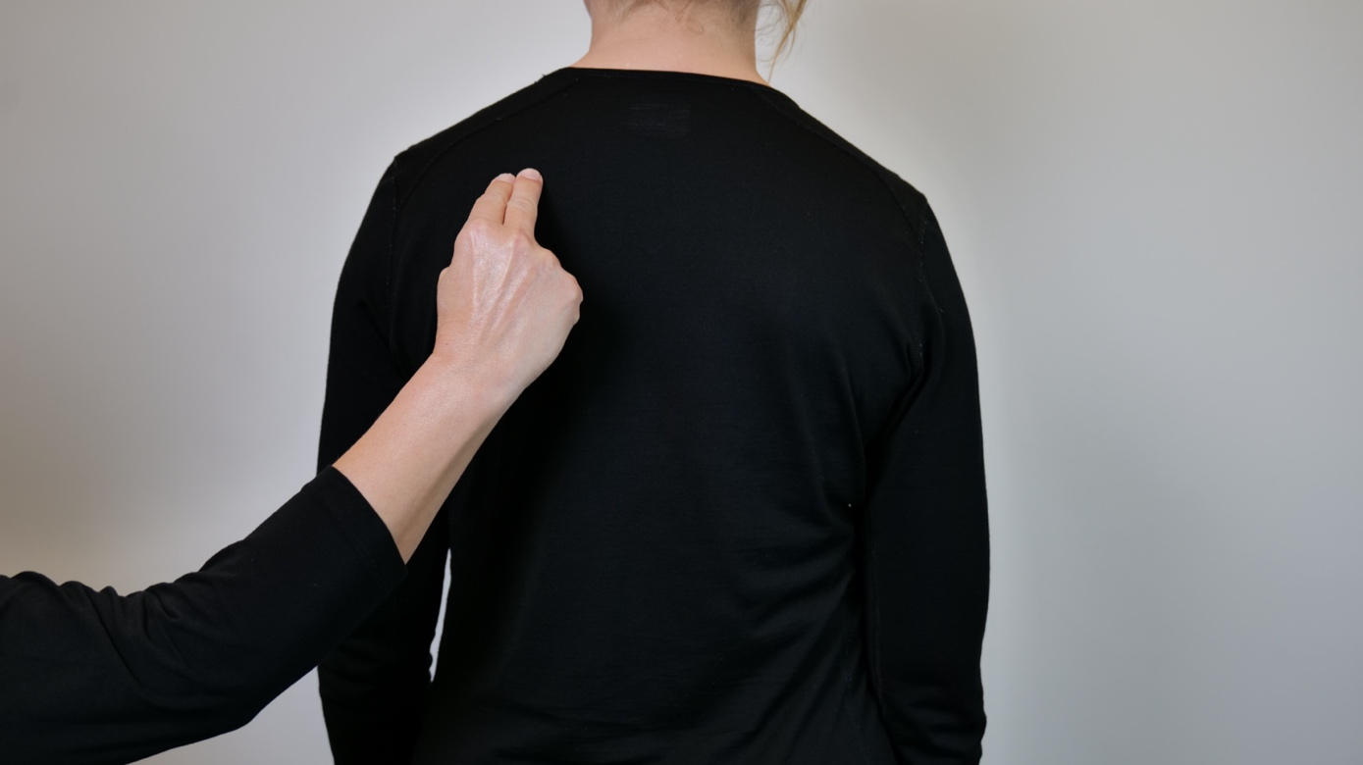

"STOP"
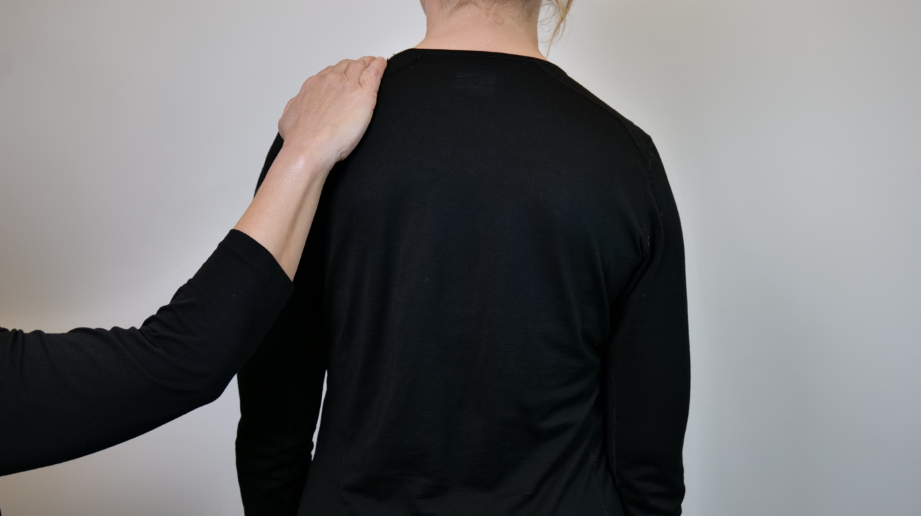
Place flat hand with palm down on receiver's shoulder, press down lightly.

"ROAD/JUNCTION/SIDE ROAD"
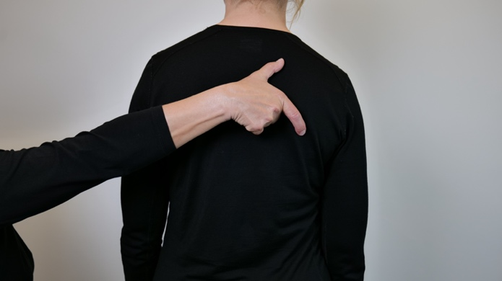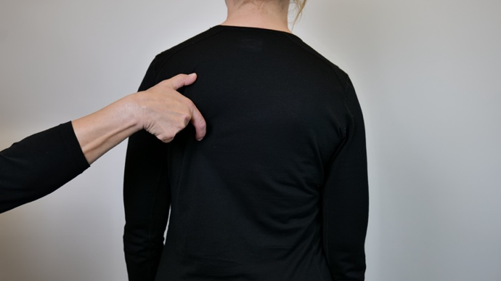
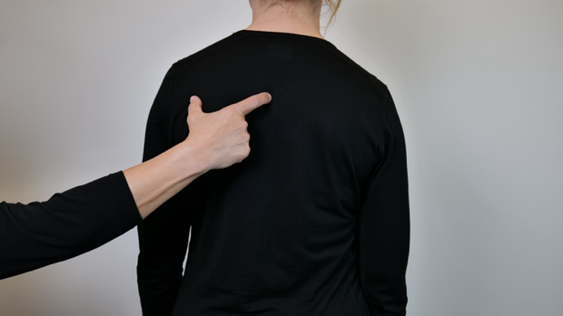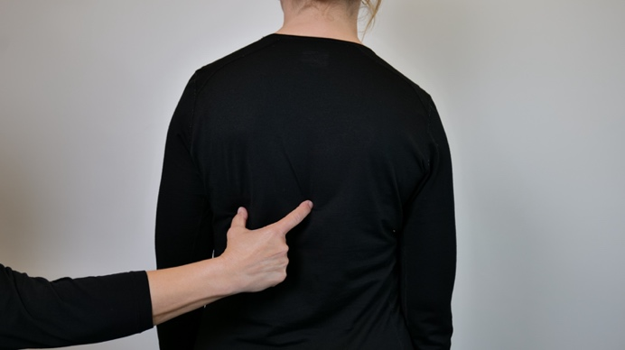
Thumb and forefinger with a good distance from each other, drag across the back where the roads are, as in a map.

"PEDESTRIAN CROSSING"
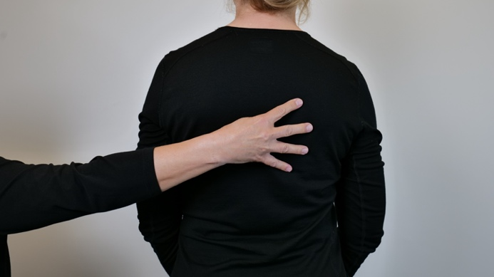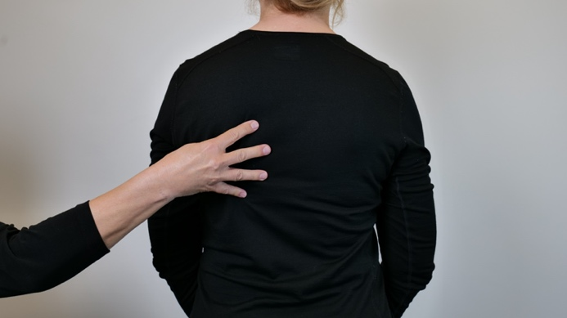
Hold the thumb against the palm, spread the other four fingers and guide these with the fingertips over the recipient's back. Place the pedestrian crossing in the previously indicated path and direction.

"Narrow PASSAGE" 1
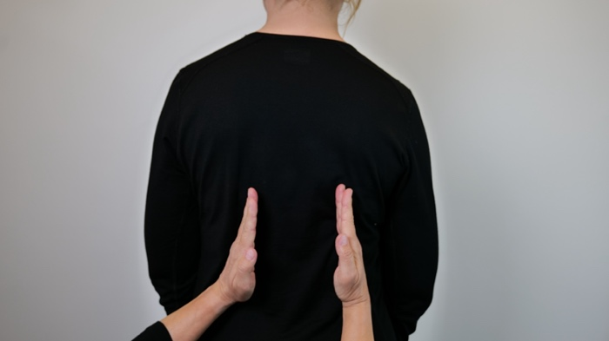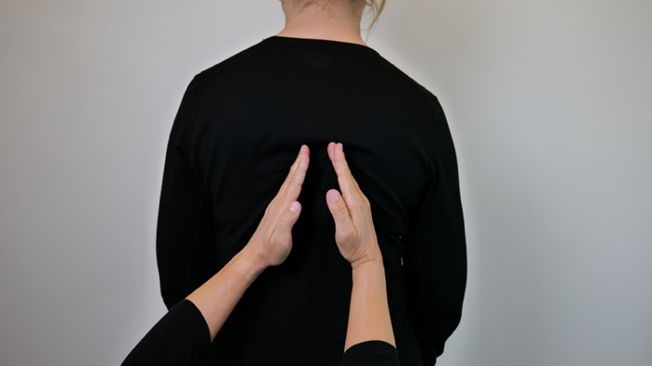
Place two karate hands at the bottom of the receiver's back, on opposite sides, but palms facing each other. Move the hands up the back as they are brought closer together, move out again when the passage is over.
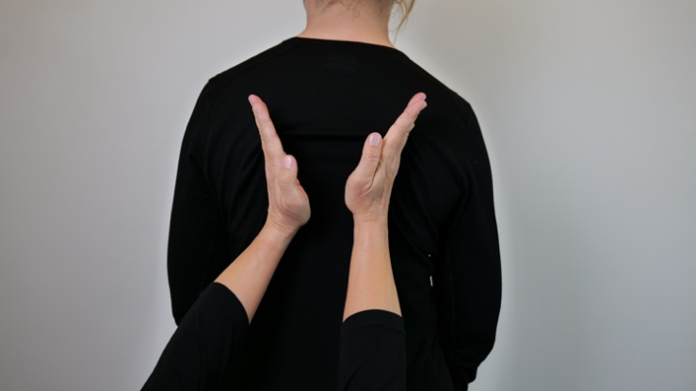

"Narrow PASSAGE" 2
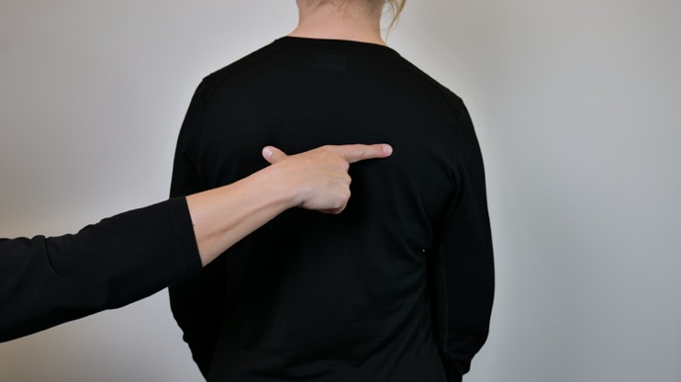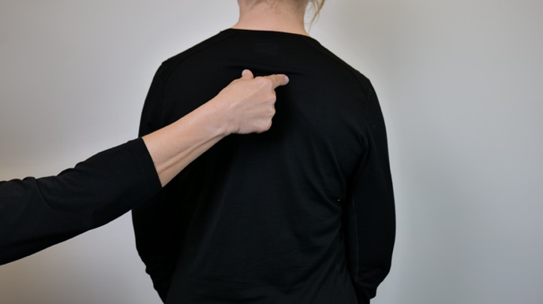
Place spreading thumb and forefinger at the top of the receiver`s back, move upwards at the same time as the fingers are drawn closer together, move out again when the passage is over.
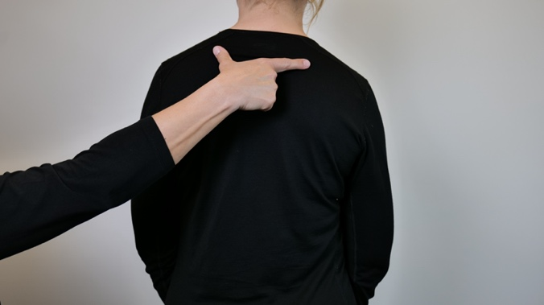

"TURN AROUND/TURN AROUND"
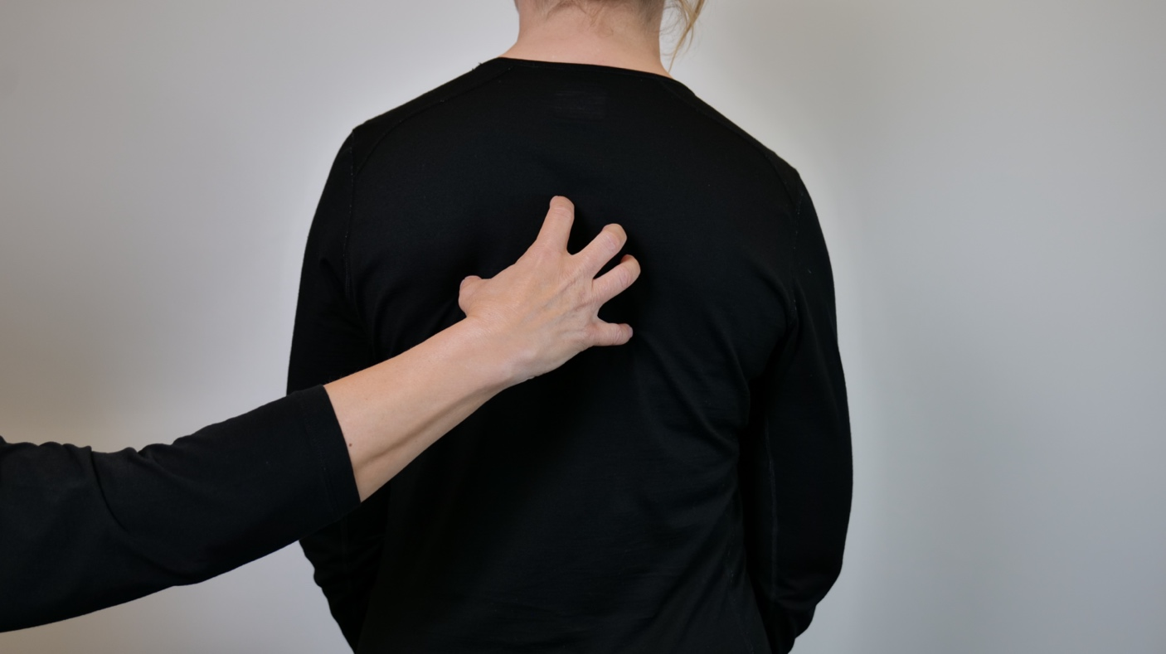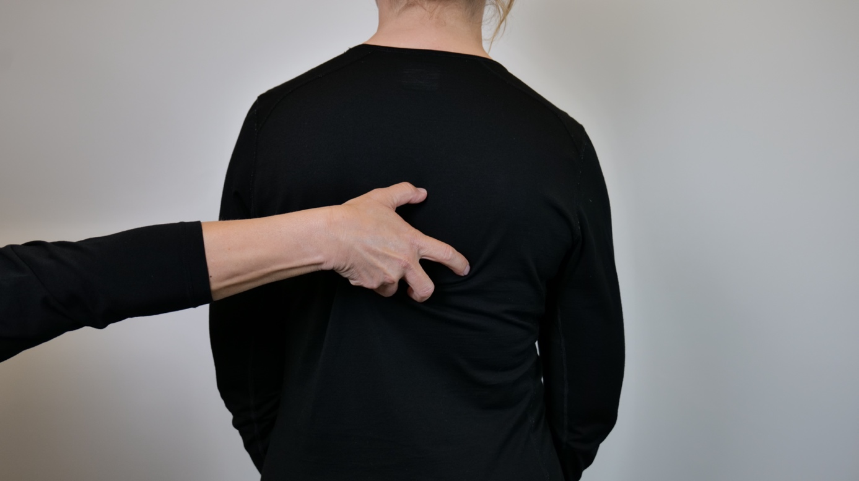
Claw hand is placed on receiver's back, flip completely like a switch. If you don't want to turn around completely, but turn 90 degrees in one direction, stop the movement first.

"TRASH BOX"
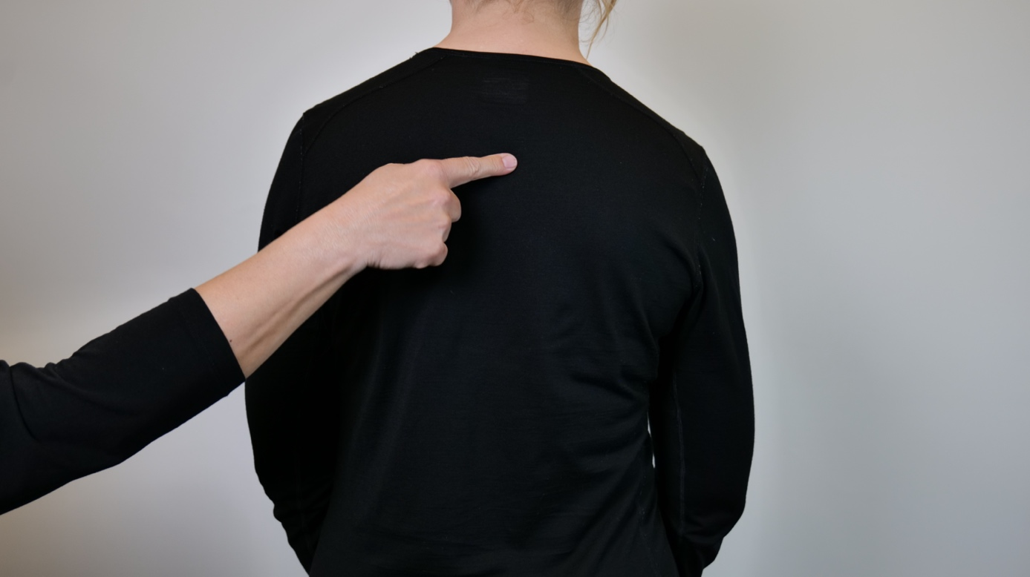
Draw a circle with your index finger on the receiver's back, then place a clenched fist in the circle,
O

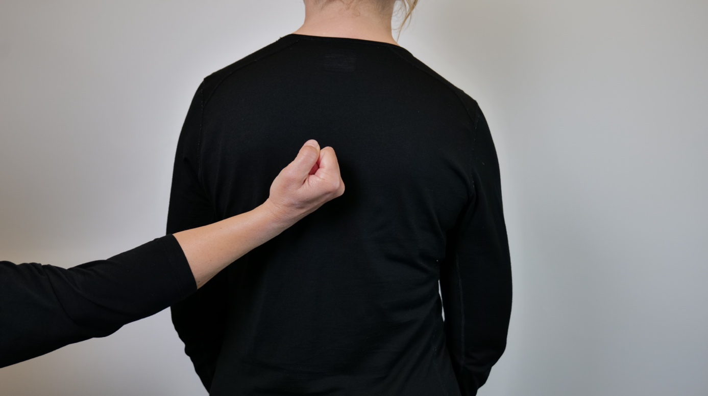

"EVERYTHING WITH WHEELS"
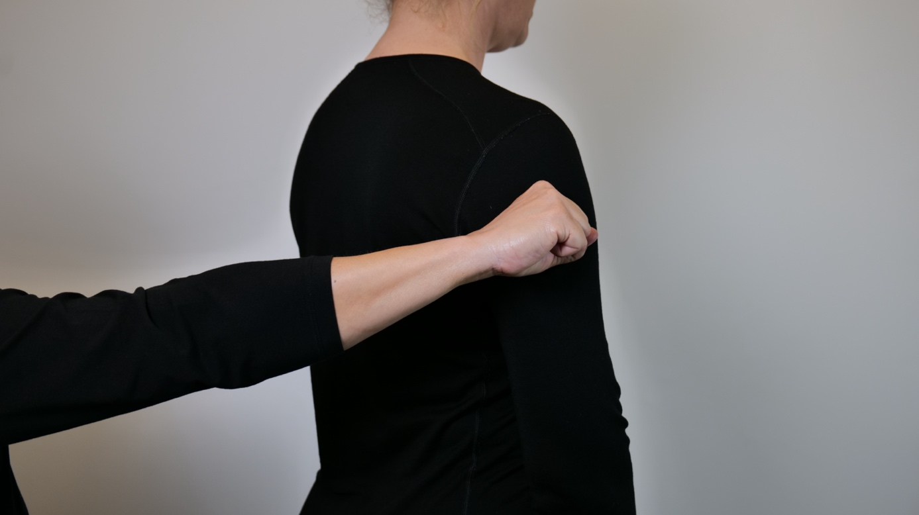
Place the clasped hand on the receiver's upper arm with the back of the hand facing up. Make a circular motion.

"STAIRCASE"
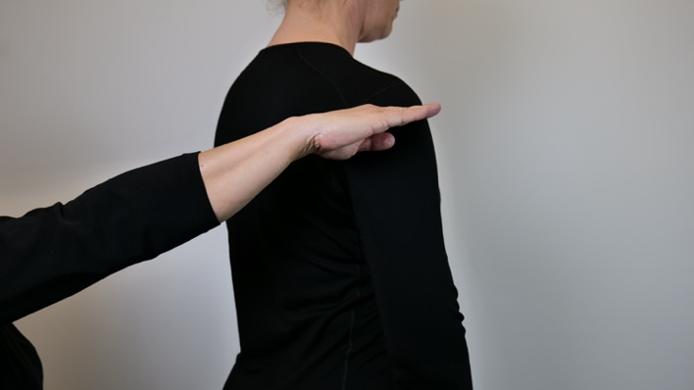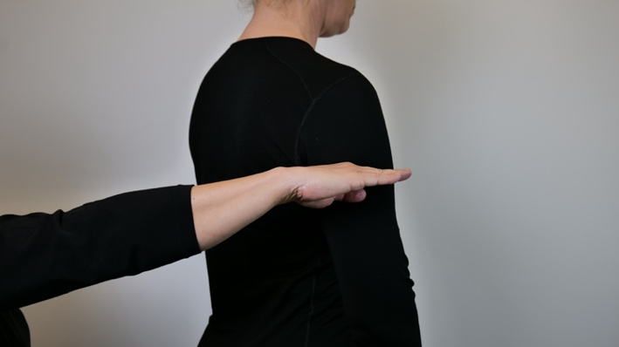
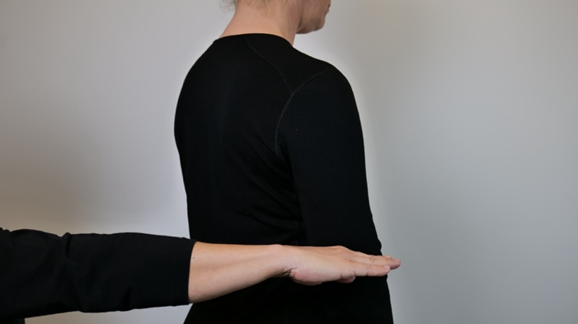
Place the flat hand with the little finger side in and the palm facing down on the receiver's upper arm. Going down the stairs, start at the shoulder and press in lightly. Repeat this at the same time as the contact point becomes longer and further down the upper arm towards the elbow.
Perform the same signal, but in the opposite direction if the stairs are going up.

"ESCALATOR"
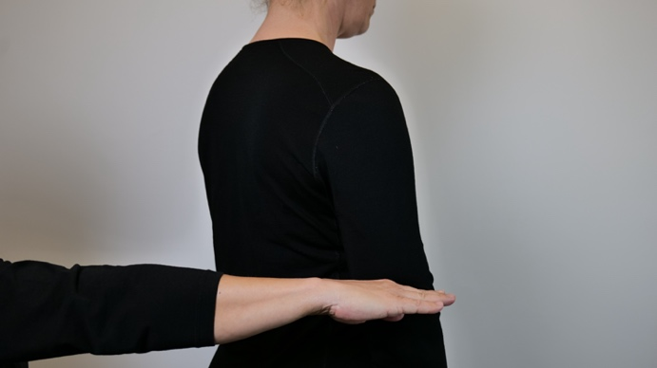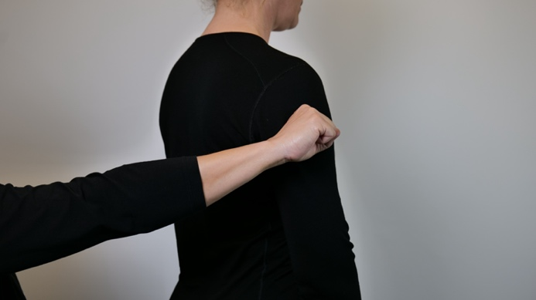
First give the signal for "Stairs" in the correct direction, then the signal for "Everything with wheels".

"DIRECTION"-Right, left, straight ahead -1
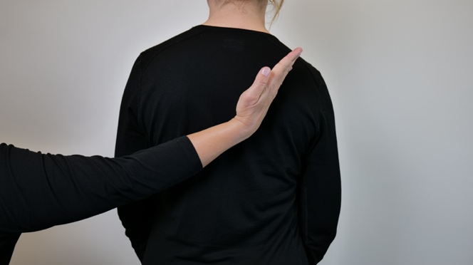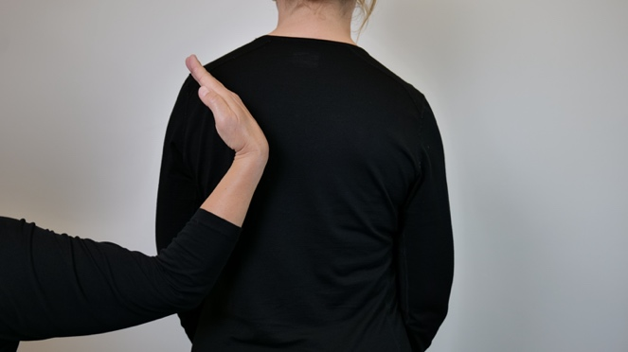
Place the karate hand with the little finger in the middle of the receiver's back, move it upwards in the relevant direction. To the right, left or straight ahead.
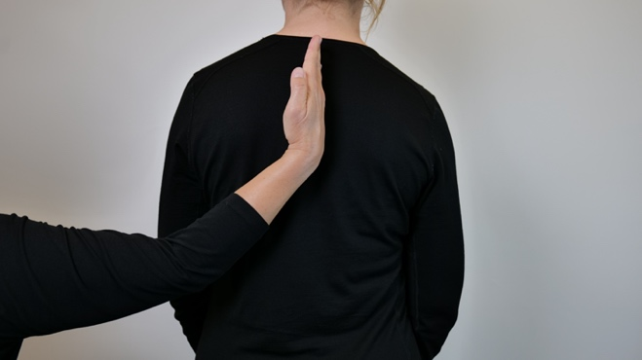

"DIRECTION"-Right, left, straight ahead - 2
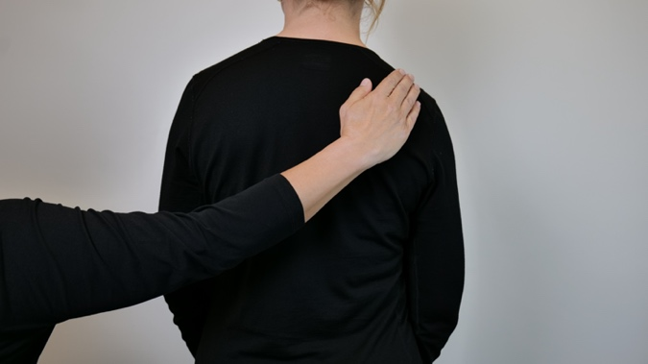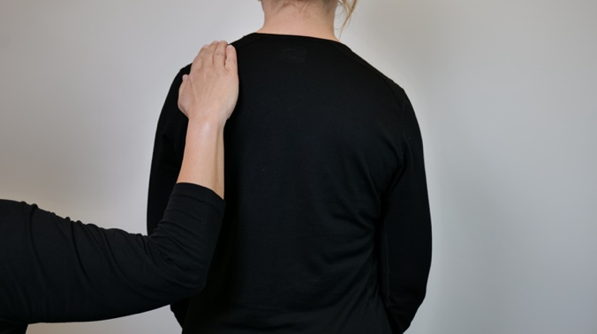
Place flat hand at the top of receiver's back. Respectively on the right side, left side or in the middle.
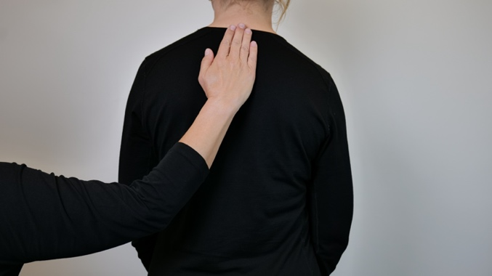

"ADJUST DIRECTION"
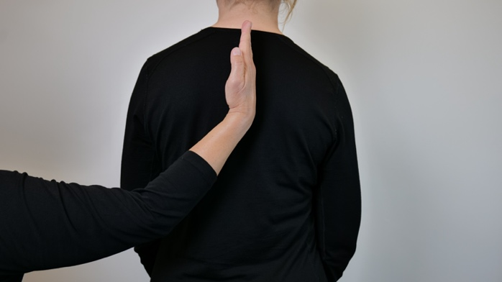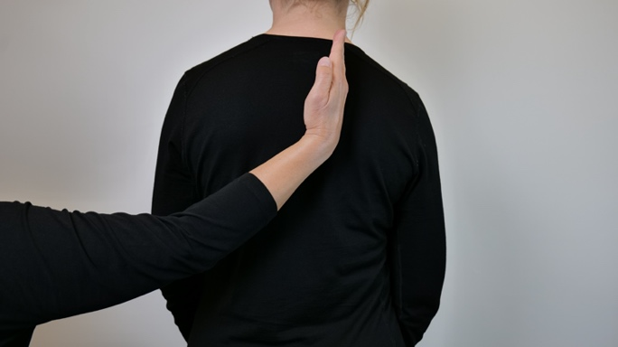
Place flat hand with little finger on top of receiver's back, slide hand horizontally to right or left to adjust direction.

"LEVEL AND GRADING"
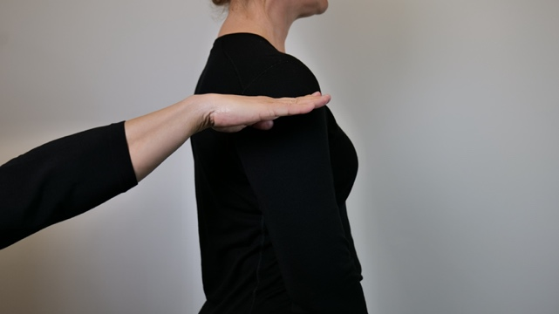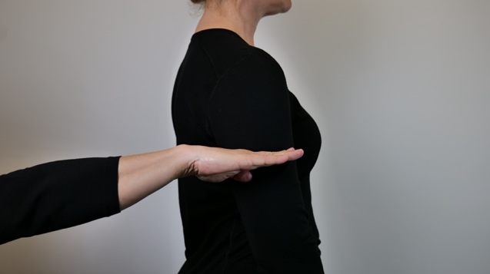
Place the flat hand on the receiver's upper arm with the palm down, either upwards or downwards on the upper arm. Everything that is big, high, ceiling, sky, full etc. is at the shoulder, everything that is small, low, floor, ground, empty space etc. is at the elbow. Grading is everything in between. Used in combination with other signals.
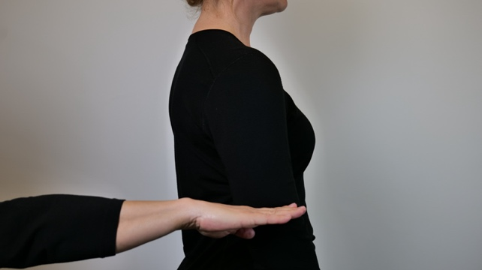

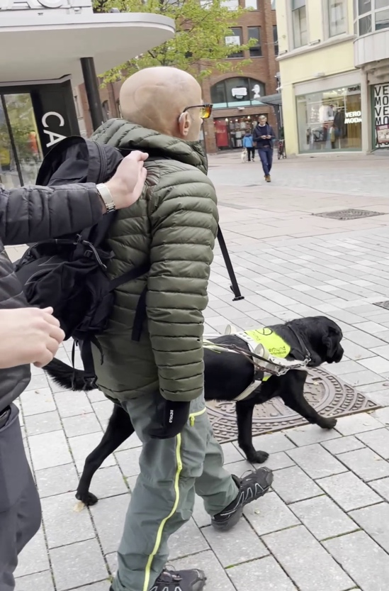

VIDEO 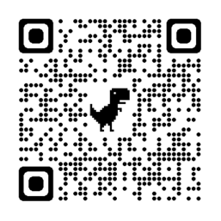

PREFACE

This project was a collaborative project between Eikholt National Resource Center for the deafblind and Hapti-Co, who are course holders and developers of Haptic communication. The project was carried out as a pilot with experienced guide dog users with combined vision and hearing loss. The guide dog schools in Norway contributed to the project.
The project was carried out at Eikholt and in the city center of Drammen in the period between October 2021 and February 2022. The result is presented in a booklet that describes 56 haptic signals. The booklet will be made available on Hapti-Cos and on Eikholt's websites.

We would like to thank:
Hege Beathe Dahlen, Synnøve Margrethe Nordeng, Marius Vincent Philipp and Nina Frisnes Øyan for wise reflections, experimentation through practical exercises and for all good the contributions

We would also like to thank the guide instructors and guide dog schools:
AnnSofie Englund Evensen from the Norwegian Association of the Blind's guide dog school, Neal Wallis from Veiviseren guide dog school and Anne Østlid and Johan Wahl from Lion's guide dog school and mobility centre.

Drammen, 3. mai 2023

Hapti-Co, Sandefjord Hapti-Co, Drammen Eikholt
Hildebjørg K. Bjørge Inger Lise Vincent Cathrine Timm Sundin

